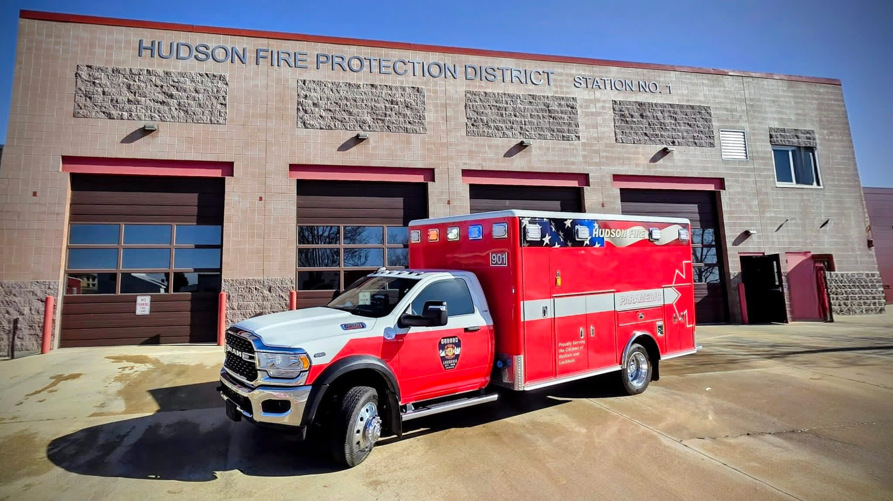  Being a career Paramedic at HFPD  - 48/96 work schedule.  - 2026 Paramedic salary range- $89,265 - $99,265 annually.  - 1% matching HSA Account.  - Medical, dental, vison benefits District pays 70% of dependent cost and 100% of employee cost.  - Matching FPPA pension.  - Generous Paid Time Off.  - Longevity Pay.  - Bi-lingual pay: if qualified.  - Education Bonuses.  - Tuition Reimbursement.  - Holiday Pay.
  About Us
  The Hudson Fire Protection District is an All-Hazards agency that serves approximately 96 square miles in southern Weld County, Colorado. We are committed to our customers, and it is our goal to provide quality fire suppression, fire prevention, life safety, and property conservation, as well as emergency medical services to the Town of Hudson, the Town of Lochbuie, and the surrounding rural areas. HFPD is a career department that responds out of two full-time staffed fire stations, which operate 24/7, 365.
  Contact us:
  Phone: (303) 536-0161
  Email: bjackson@hfpdco.org
  Web: www.hfpdco.org
  Visit us on Facebook!
  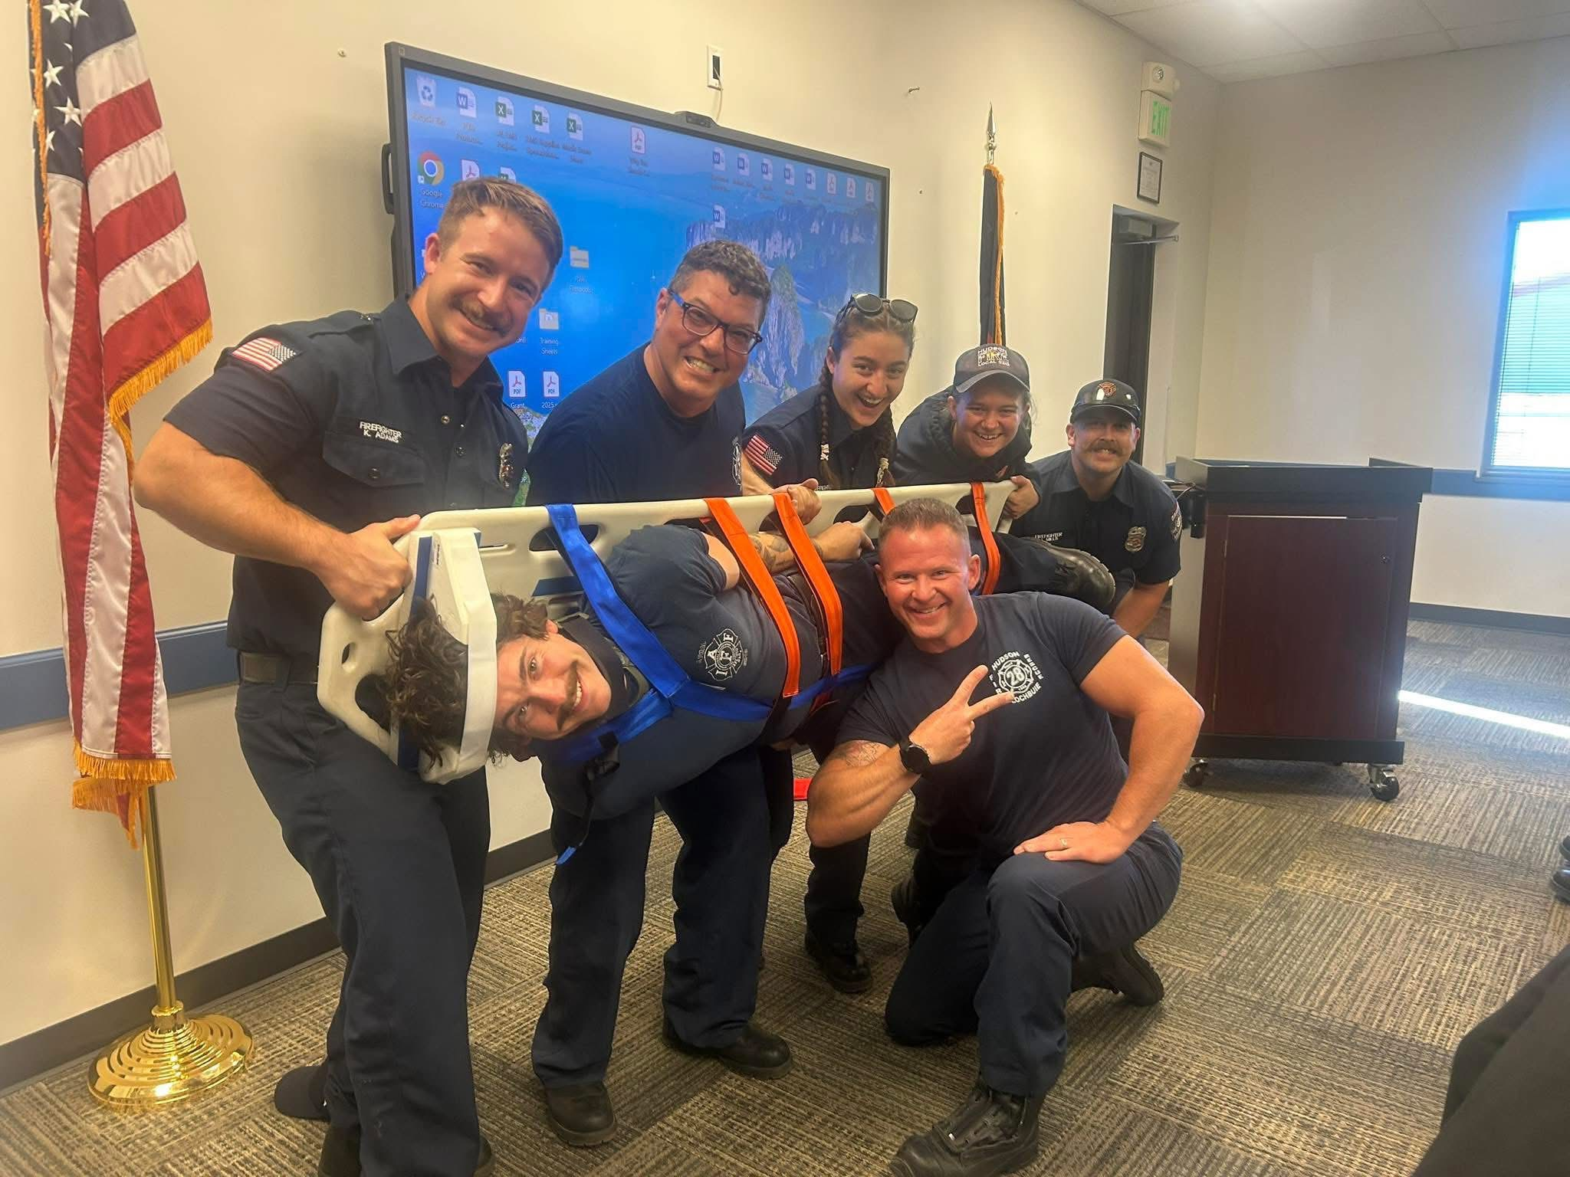
  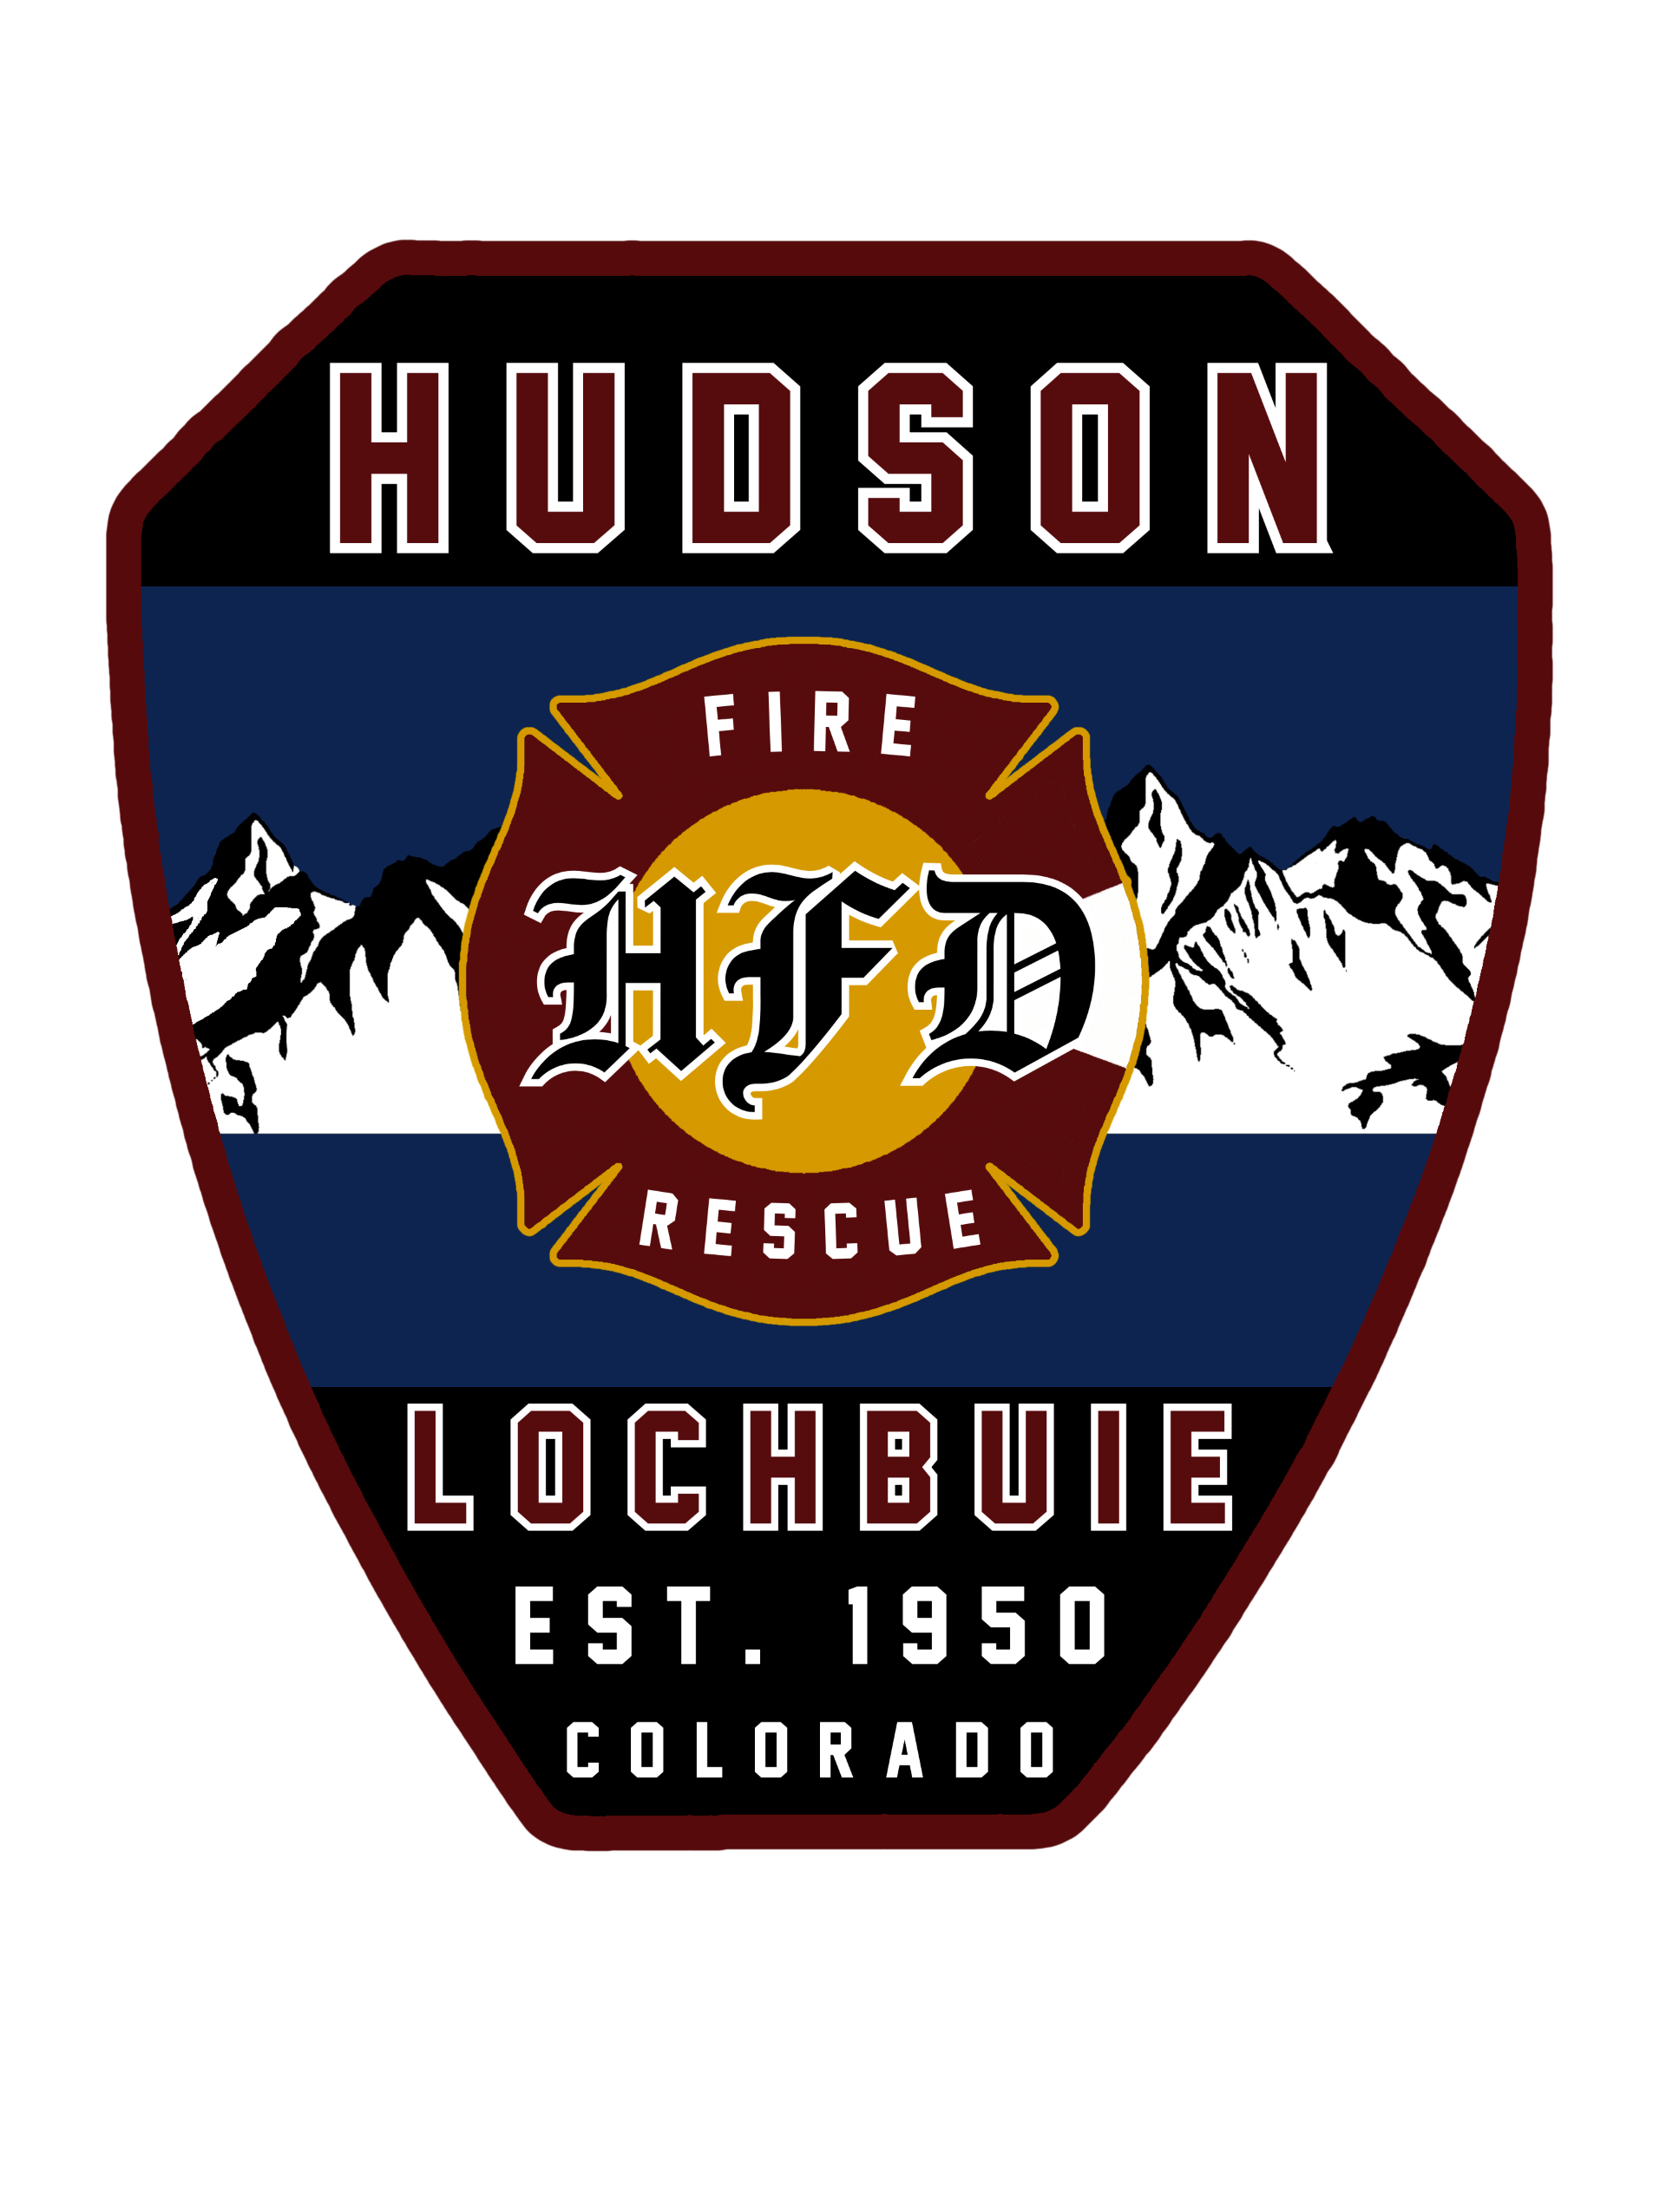
  Hudson Fire Protection District
    - “Aggressively and safely protect life, property, and the environment by providing excellence in emergency services, training and prevention.”

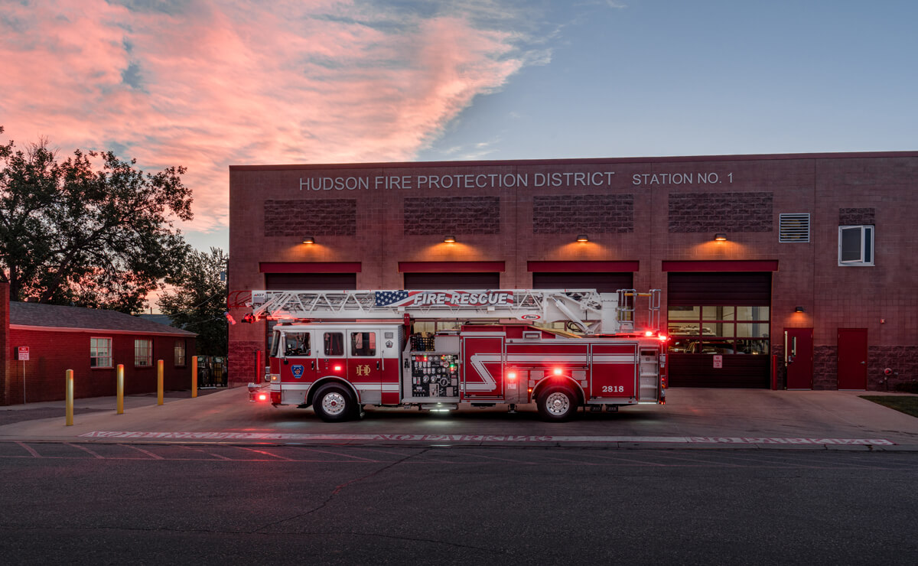  What’s required to become a Career Paramedic at HFPD  - Be 18 years of age.  - Possess a High School Diploma or GED  - Valid Drivers License & must be able to possess a Colorado Driver’s License within 1 year of hire.  - Current ACLS & PALS Certifications  - Current Colorado or National Registry EMT-Paramedic  - Current CPR and AED Certification  - Current CPAT |  |  | Want to have a specialty?  - Wildland Team- Deploys nationwide.  - Field Training Officer (FTO)  - Public Education  Applications being accepted until March 31st at 3:00 pm  Please send your completed application with resume, cover letter, complete driving record, and all required certifications to Division Chief Calvin Brown:  Cbrown@hfpdco.org  Application available online - www.hfpdco.org |  |  |   As a career Paramedic with HFPD, you have the option to become part of our growing union: Hudson Professional Firefighters, Local 5213. Visit our website Facebook: HPFA5213  