Job Opportunity: Full/Part-Time Cook at Stewartstown American Legion Post #455

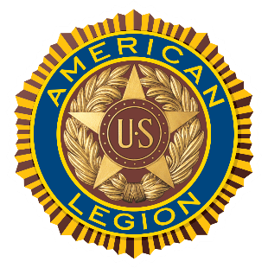
Position Summary
The Stewartstown American Legion Post #455 is seeking a dedicated and enthusiastic Full-Time or Part-Time Cook to join our kitchen staff. Located at 19222 Barrens Rd, South Stewartstown, PA, we are seeking an individual passionate about delivering high-quality food in a friendly, professional environment.

Key Qualifications & Requirements
- Experience: Previous professional cooking experience is highly valued, though not strictly required.
- Training Opportunity: We are committed to developing talent. Comprehensive, hands-on training will be provided for the right candidate who demonstrates a strong work ethic and willingness to learn.
- Advancement Potential: This role offers genuine opportunities for professional growth and advancement within our organization.

What We Offer
- Positive Work Environment: Join a great team in a cooperative, safe, and friendly atmosphere.
- Team Focus: Be a key player in a supportive organization that values teamwork and quality service to our members and guests.

To Apply
Interested candidates are invited to inquire about this opportunity by contacting:
Jim (843) 333-3557 or send your resume to Amlegionpost455@zoominternet.net
Website: https://stewartpost455.org

