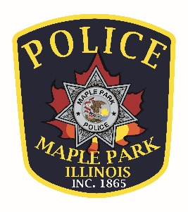
Maple Park Police Department
Part – Time Police Officer
The Village of Maple Park is accepting applications for Certified Part-Time Police Officers!
The Village of Maple Park Police Department is seeking motivated, professional, and community-oriented individuals to join our team as Certified Part-Time Police Officers. Applicants must be currently certified or eligible for certification as a law enforcement officer in the State of Illinois.
This position offers an opportunity to serve a growing community while working alongside dedicated law enforcement professionals committed to public safety, integrity, and community policing.
Qualified applicants should possess strong communication skills, sound judgment, and a commitment to providing exceptional service to the residents of Maple Park.
The Village of Maple Park is an Equal Opportunity Employer.
JOB DESCRIPTION
Join the Village of Maple Park’s Police Department as a Part-Time Police Officer. The Police Department is one of the most visible Village departments and works to keep the Maple Park community safe and oversees the enforcement of laws and ordinances.
The Part-Time Officer will perform general and specialized law enforcement duties in order to preserve public peace; to protect lives, property, the rights of the public; and to enforce statutory laws and municipal ordinances. To perform this job successfully, an individual must be able to perform each essential duty exceptionally. Community policing is a key element of this position. The requirements listed below are representative of the knowledge, skill and / or ability required.
Flexible schedule - Police position will be shift-work which may include weekdays, weekends, and holidays. Shift length options may be 8, 10 or 12 hours.
REQUIRED KNOWLEDGE, SKILLS, AND ABILITIES:
- Must be 21 years of age or above
- Possess a High School Diploma or GED certificate
- Possess a valid Illinois driver’s license
- Possess a valid Illinois FOID card
- Must have graduated from either a full-time police academy or a part-time academy approved by the Illinois Law Enforcement Training and Standards Board and have served as a certified police officer
- Qualified in the use of firearms
- Ability to be certified in CPR/AED and First Aid.
- Must have a clear record with no arrests involving violent crimes and / or felonies
- Pass a medical examination and drug test
- Anyone who has served in the US Military must have been honorably discharged
- Able to understand and carry out complex oral and written instructions
- Exercise initiative and discretion in emergency situations
- Make decisions based upon department policies and training
- Have good communication skills
- Ability to become proficient with required software and computer-based systems
- Work without direct supervision
- Must have a working knowledge and/or the ability to access information in criminal and traffic law, and department policy
- Be of good moral character, of temperate habits, of sound health, and physically and mentally able to perform assigned duties
- Attend training as required
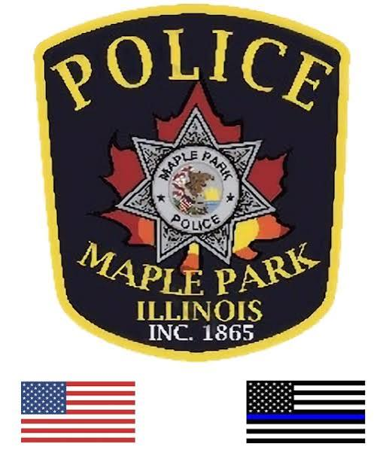
- Establish positive relationships with the community

SALARY

- Starting pay is $31.50 per hour
- Time and a half pay on designated holidays and details.

HOW TO APPLY

Qualified applicants should apply by completing an application and attaching a resume and cover letter and three references. Application can be found on The Village of Maple Park’s website at https://villageofmaplepark.org/employment/.

Please mail to: Maple Park Police Department
Chief Randy Endean
306 Willow Street
P.O. Box 148
Maple Park, IL 60151
Or email to: rendean@villageofmaplepark.com



