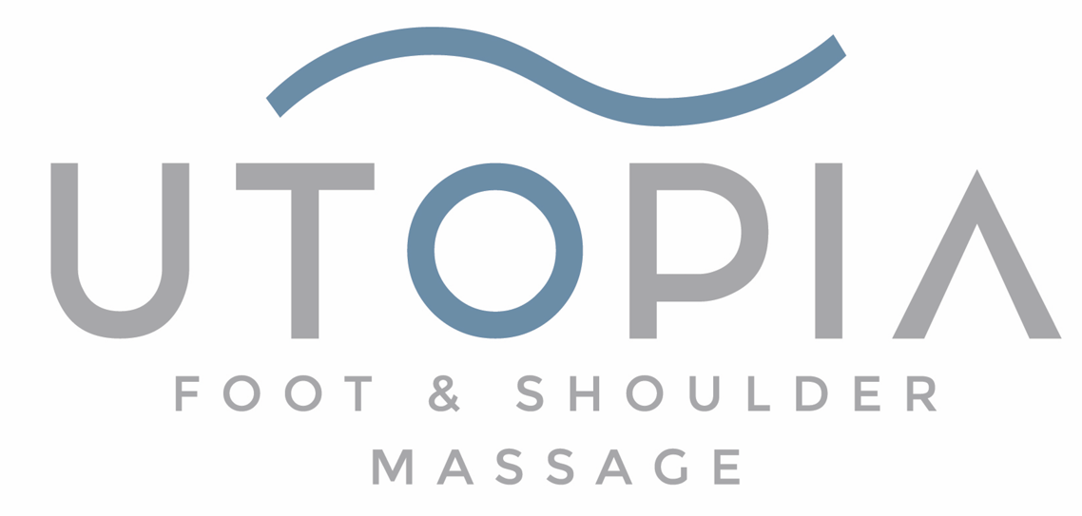
Massage Therapist – Join Our Team
Utopia Foot & Shoulder Massage | Grant Park & Smyrna
We are looking for reliable, professional foot, back + shoulder Massage Therapists to join our growing local business. Experience is preferred, but training is available for the right person.
At Utopia, we believe great massage starts with great hospitality. We care deeply about customer service, creating a welcoming environment, and maintaining a drama-free workplace. We are a team that values kindness, professionalism, and consistency.

Compensation Includes:
- Paid Daily Rate
- Commission
- Gratuity
- Annual Bonus
- Birthday Bonus
- Holiday Bonus

What We’re Looking For:
- Strong customer service and hospitality skills
- Positive attitude and team mindset
- Reliable and punctual
- Professional appearance and communication
- Ability to work in a peaceful, no-drama environment
- Must provide work references
- Must be legally authorized to work in the U.S.

Locations:
- Grant Park
- Smyrna
If you take pride in your work and want to be part of a respected local business that values both clients and employees, we would love to meet you.

