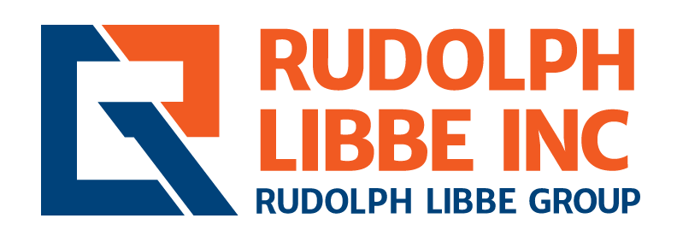

JOB TITLE: Quality Assurance and Quality Control Manager
DEPARTMENT: Construction Operations
LOCATION: Walbridge, Ohio
REPORTS TO: Mike Mutscheller, Vice President of Construction Operations

JOB DESCRIPTION
The Rudolph Libbe Group is a leading, full-service provider of construction and facility solutions headquartered in Walbridge, Ohio. Founded in 1955, RLG operates as a single-source partner for clients across diverse industries, offering expertise in construction management, design-build, energy solutions, and ongoing facility maintenance.
Our organization is comprised of multiple companies working together as one team. This integrated structure allows us to deliver everything from site selection and financing to construction, renovation, and long-term facility management, ensuring seamless service and exceptional results. At RLG, we pride ourselves on a safety-first culture, collaborative approach, and commitment to quality, making us one of the top contractors in the nation.
Rudolph Libbe Inc. is searching for a strategic professional to join our growing team as a Quality Assurance and Quality Control (QA/QC) Manager in our Walbridge, Ohio office. The QA/QC Manager provides strategic leadership and operational oversight for the company’s Quality Management System (QMS) across all construction projects and business units. This role ensures that construction practices, materials, field workmanship, and deliverables consistently meet or exceed contractual requirements, industry standards, regulatory expectations, and client needs. This role drives a culture of excellence, accountability, and continuous improvement through standardized processes, proactive risk mitigation, field support, and data-driven decision-making. Working closely with Operations, Safety, and Executive Leadership, this position ensures that quality performance supports overall business success and client satisfaction.

JOB RESPONSIBILITIES
- Develop, implement, and maintain a company-wide Quality Management System.
- Establish corporate quality policies, procedures, and performance metrics.
- Lead quality planning efforts from preconstruction through project closeout.
- Integrate quality objectives into business planning and executive reporting.
- Represent the organization in client meetings, preconstruction sessions, and industry forums.
- Develop long-term strategies to improve first-time quality, reduce rework, and enhance client satisfaction.
- Oversee quality performance across all regions and project types, including self-performed and subcontracted work.
- Conduct site visits, audits, and inspections to verify compliance with specifications, codes, and contractual requirements.
- Ensure effective standardization and implementation of project-specific Quality Plans, quality procedures, and hold-point verifications.
- Monitor quality performance across all active construction projects.
- Support project teams in resolving quality issues and implementing corrective actions.
- Oversee management of non-conformance reports (NCRs), rework logs, and field-testing documentation.
- Analyze quality data, trends, and root-cause findings to reduce rework and improve first-time quality.
- Collaborate with Safety, Operations, and Risk Management to align quality with incident prevention, warranty control, and long-term reliability.
- Standardize tools, templates, dashboards, and reporting systems to drive consistency and transparency.
- Oversee internal quality audits and third-party inspection coordination.
- Promote continuous learning through root-cause reviews, field observations and cross-project sharing of lessons learned and best practices.
- Serve as the primary corporate point of contact for clients, auditors, and regulatory agencies on quality matters.

SKILLS
- Strategic mindset with strong operational execution.
- Technical and regulatory expertise.
- Leadership and influence across diverse teams.
- Data-driven decision-making and analytical insight.
- Client-focused communication and professionalism.
- Strong attention to detail, risk mitigation, and continuous improvement.

EDUCATION/EXPERIENCE
- Bachelor’s degree in Construction Management, Engineering, or related field.
- 10+ years of progressive experience in construction quality management, including leadership of multi-project or corporate-level programs within a self-performing general contractor or construction manager.
- Strong technical knowledge of civil, structural, architectural, and MEP systems.
- Experience with ISO 9001, CQM, ASQ methodologies, or equivalent certifications preferred.
- Proficiency in construction and quality management software.

HIRING MANAGER: Mike Mutscheller, Vice President of Construction Operations
POSTING PERIOD:
POSTING LOCATIONS: All Rudolph Libbe Group offices

Interested parties should apply on our website at www.rlgbuilds.com/careers.

Rudolph Libbe Inc. is an Equal Employment Opportunity Employer.

