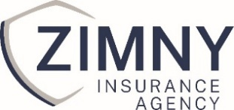
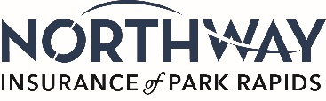

Join our Insurance Team!
Commercial Lines Account Representative
Zimny Insurance Agency-Northway Insurance is a locally owned and operated business proudly serving Alexandria and Park Rapids area and surrounding communities. As a small, community-focused agency, we take a personal approach to everything we do—whether it's helping clients protect what matters most or supporting the growth of our team. We’re currently seeking a detail-oriented, client-focused Commercial Insurance Account Representative.

Job Summary:
As a Commercial Insurance Account Representative, you will support producers and clients by managing commercial insurance accounts, handling renewals, endorsements, certificates of insurance, and ensuring timely and accurate service. You’ll be a trusted resource for clients, providing outstanding customer service and maintaining strong relationships.

Key Responsibilities:
- Manage a book of small to mid-sized commercial accounts.
- Process policy renewals, endorsements, audits, and cancellations.
- Respond promptly to client inquiries and resolve issues effectively.
- Prepare certificates of insurance and other documentation.
- Communicate with insurance carriers for quotes, changes, and claims assistance.
- Maintain accurate records in the agency management system.
- Assist producers with marketing and placement of new business.
- Stay up to date with industry changes, products, and compliance requirements.
Key Qualities for Success:
- Excellent communication skills – Able to communicate clearly and professionally with clients, carriers, and teammates.
- Empathy and patience – Understand client concerns and responds calmly and supportively.
- Advocacy – Genuinely represents the client’s best interests while maintaining professionalism with carriers and team members.
- Strong problem-solving abilities – Finds effective solutions and resolves issues with confidence.
- Humble professionalism – Approaches work with confidence and competence, without ego; open to feedback and growth.
- High attention to detail – Ensures accuracy in all documentation and client interactions.
- Effective time management – Capable of handling multiple priorities and meeting deadlines.
- Adaptability – Comfortable with change and able to adjust to evolving client or business needs.
- Self-motivation and initiative – Demonstrate the ability to work independently with minimal supervision while also collaborating effectively within a team setting
Compensation and Benefits:
- Competitive salary based on experience.
- Health, Vision, Life & Disability insurance.
- 401(k) with company match.
- Paid time off and holidays.
- Continuing education support.

Work Hours (Full Time 40 hours week) in our Alexandria office:
Monday- Friday 7:30am-4:30pm with a one-hour lunch or 8:00am-4:30pm with a ½ hour lunch

How to Apply:
Please submit your resume and a brief cover letter explaining why you're a good fit for this role to chrism@zimnyins.com or mail to: Zimny Insurance Agency
Attn: Chris Mohr
1103 Broadway St, Ste 100
Alexandria, MN 56308

With a strong commitment to excellence and personalized service, we guide our clients through the complexities of insurance with clarity and confidence. If you're looking for a meaningful role in a locally owned business that values relationships over red tape, we’d love to hear from you.

