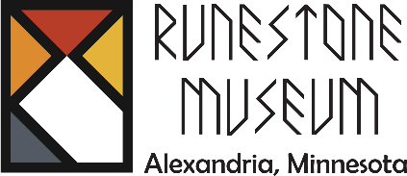
206 Broadway St.
Alexandria, MN 56308
320-763-3160

Part-Time or Full-Time Seasonal Customer Service Associate

Job Type: Seasonal
Hours: Museum summer hours: 10a-4:30pm. (Weekend availability required, with weekday shifts)
Compensation: Competitive hourly wage (Based on experience)

About Us:
The Runestone Museum is a historical and cultural institution dedicated to preserving and showcasing the rich heritage of Alexandria, MN. We provide an engaging experience for visitors through exhibits, events, and educational programs.
Position Summary:
We are seeking a friendly and reliable Customer Service Associate to assist with front desk operations, gift shop sales, and visitor engagement during our busy season. This role requires Saturday availability and is ideal for someone who enjoys interacting with the public and sharing local history. Work schedules are flexible and this position can be either full-time or part-time.
Previous work experience is not required, but is helpful.

Key Responsibilities:
- Opening and closing procedures for the museum and Fort Alexandria.
- Greeting visitors warmly, process admissions, memberships, and gift shop sales using a point-of-sale (POS) system.
- Answer phone calls, respond to visitor inquiries, and provide information about exhibits and events.
- Assist with light housekeeping and organizing merchandise in the gift shop.
- Monitor visitor activity to ensure a positive and safe experience.
- Support museum staff with special events and other duties as needed.

Qualifications:
This is a customer service position that requires positive interpersonal and communication skills. It is great if you have previous work experience, but it is not required. Interest in history and/or working in a museum is a plus.
- Ability to work independently and as part of a team.
- Must be available to work weekends and occasional holidays.

If you love interacting with people and have a passion for history, we’d love to have you on our team!

📩 To Apply: Submit your resume and a brief cover letter to Barbara Haacke, Executive Director at director@runestonemuseum.org. You may also drop off your application at the museum.

