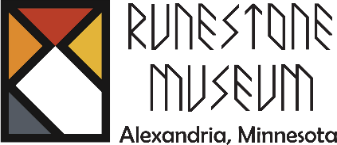
206 Broadway St.
Alexandria, MN 56308
320-763-3160
www.runestonemuseum.org
_________________
Administrative Coordinator
Job Purpose
Provide operational and administrative support to the Executive Director and to the museum’s growing scope of programming while adhering to the museum’s mission. Be the point of contact for Museum Store management and performance.

Primary Duties and Responsibilities
Management
- Provide leadership and oversight for the day-to-day functioning of the museum gift shop, tour groups, special events, answer and direct incoming calls. Maintain the museum calendar, schedule and prepare for group tours, hire and schedule volunteers. Flexible and positive team player able to prioritize and manage multiple projects simultaneously while following through in a timely manner. Independent judgement is required to plan and prioritize a diverse workload.

Gift Shop
- Greet visitors and create a welcoming museum experience.
- Track Museum Store sales, inventory and trends.
- Assist with merchandising gift store items, run errands for the museum.
Volunteer Coordinator:
- Assist in hiring, training, and scheduling volunteers.
Membership
- Maintain museum membership, sponsorships, and donations correspondence.

Administration
Help ensure smooth and efficient operation of the museum. This person will be well-organized and is able to multi-task. Order and receive store supplies, maintain website and online calendar, schedule group tours, schedule volunteer tour guides, assist with social media marketing and event execution. Assist in planning, scheduling, and facilitating special events.
- Software: Strong knowledge of Microsoft Office (Word, Excel. PastPerfect (will train), Outlook, P.O.S. operating systems
- Act as a project manager for special projects at the request of the Executive Director.
- Must be available Monday through Saturday (5-day work schedule).

Qualifications
Education and Experience
- Associate’s degree required (bachelor’s degree preferred). Post secondary education in business, computers, or office management is an asset.
- Interest in history and/or museum operations is desirable.
- Prior hospitality, service industry, and/or event planning experience is a plus.

Expectations
The person in this position needs to be self-motivated, can work autonomously as well as in a group with volunteers and co-workers, have excellent communication and interpersonal skills, and can assemble highly sensitive and confidential information with discretion.
- Excellent attention to detail and a strong personal work ethic.

