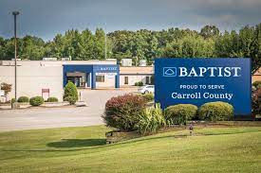
Family Medicine Residency Faculty Appointment -
Baptist Memorial Hospital – Carroll County
Baptist Memorial Hospital Memphis – Family Medicine Residency is seeking a Family Medicine physician to allow for the continued growth of our residency program at Baptist Memorial Hospital – Carroll County.
RESPONSIBILITIES AND FACILITY DETAILS:
- Core faculty appointment – site leader for rural track
- Work collaboratively with Memphis Family Medicine Residency Program
- See patients in outpatient clinic setting 3-4 days/week
- Allotted administrative time
- Duties include but not limited to:
  - Resident/faculty evaluations, academic planning, addressing disciplinary matters
- Precept residents in clinic setting
- Great work/life balance
- Employed opportunity with Baptist Medical Group

QUALIFICATIONS AND SKILLS:
- Board Eligible or Board Certified in Family Medicine
- Must have interest in faculty appointment

COMPENSATION AND BENEFITS:
- Incredibly competitive salary and sign on bonus
- Relocation assistance
- Comprehensive Benefits Package including Retirement
- Learn more at:
Medical Services | Baptist Memorial Hospital-Carroll County (baptistonline.org)

This opportunity is located in a city with small-town feel in the back yard of a major metropolitan city.

- No state income tax with low cost of living
- Approximately 2 hours to Memphis or Nashville
- Wonderful people and southern hospitality

Learn more about Huntingdon: Welcome to Our Town - Huntingdon, TN | (huntingdontn.com)

