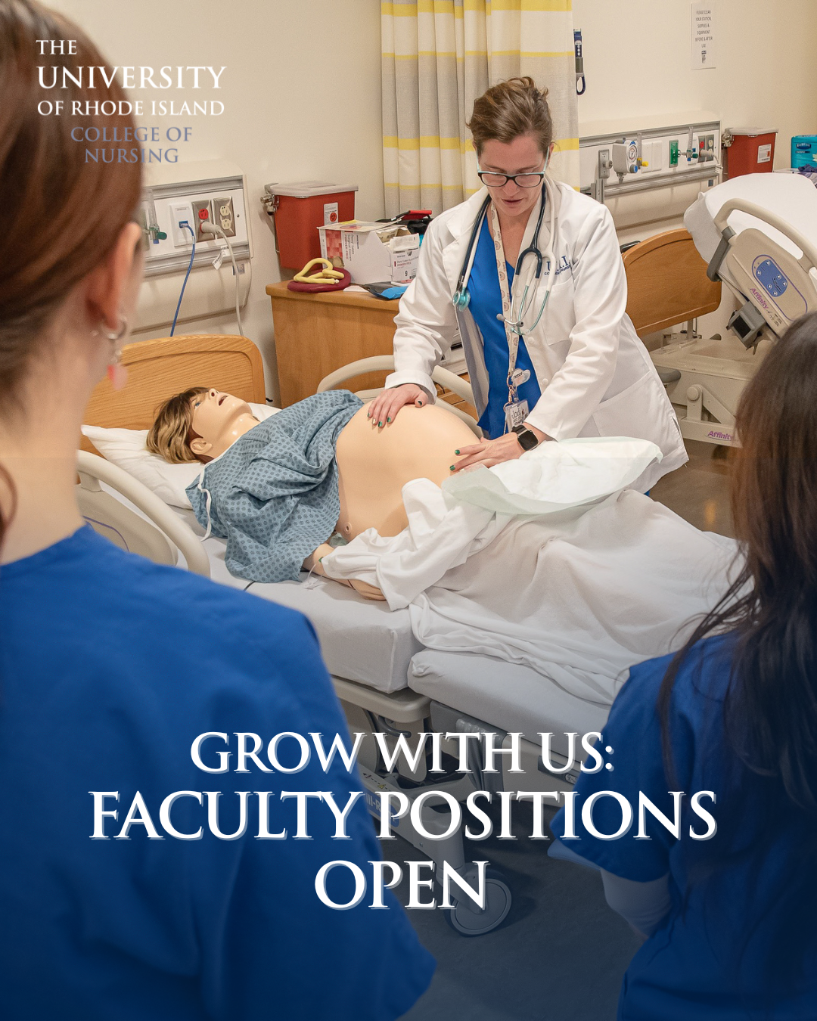

URI’s College of Nursing is growing, and so is our faculty!
Join Rhode Island’s #1 ranked nursing program, placed in the top 10% nationally (U.S. News 2024 & 2025). As enrollment rises across our BS, MSN, DNP, and certificate programs–including the state’s only Nursing Ph.D.–we’re seeking educators, researchers, and leaders who are ready to shape the next generation of nurse leaders transforming wellbeing and environments.

Explore current openings and apply today: https://bit.ly/4pubH0S

