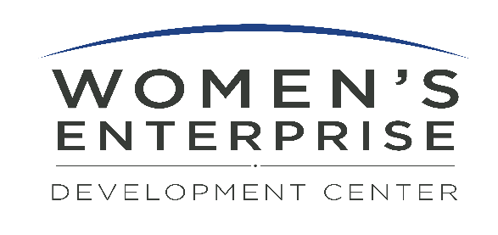
Job Title: Bilingual Entrepreneur Support Specialist - Temporary to Permanent Non-Exempt Position.
Location: White Plains, NY
Organization: WEDC (Women's Enterprise Development Center)
Compensation and Expected Hours: $30/hr. - $33.50/hr.; approx. 32 hours per week

About WEDC: WEDC is dedicated to empowering entrepreneurs and business owners by providing them with the resources, education, and support they need to succeed. We are looking for a driven, self-motivated bilingual (English/Spanish) expert to join our team as a Bilingual Entrepreneur Support Specialist.

Position Overview:
The Bilingual Entrepreneur Support Specialist will play a key role in guiding and supporting entrepreneurs and business owners as they launch, manage, and expand their businesses. This position involves providing personalized guidance, creating and leading training sessions, and crafting strategies to help our clients achieve sustainable success. This role is funded through and operates as part of WEDC’s NYS Entrepreneur Assistance Center (EAC) program, aligning closely with state-supported initiatives designed to strengthen and grow small businesses across our region.

This position requires periodic evening and weekend hours to support programs and events. The standard work schedule will generally include one remote workday, two days based in our White Plains office, and one day based in Poughkeepsie. Scheduling will be planned in advance whenever possible to support operational needs. A strong commitment to WEDC's mission and values is essential.

Key Responsibilities:
- Business Planning Support: Assist clients in developing comprehensive business plans, including defining business goals, strategies, and financial projections.
- Financial Guidance: Help clients understand financial statements, manage cash flow, secure funding, and develop budgeting strategies. Assist in preparing loan packages.
- Marketing and Sales Support: Offer clients guidance on marketing strategies, branding, customer acquisition, and sales techniques to enhance business growth.
- Provides MWBE Certification Assistance: Assist and counsel clients in English and Spanish. Report and follow up on the status of clients’ applications on a periodic basis. Document counseling sessions for input to databases to meet grant requirements.
- Training and Workshops: Lead and develop training programs on various business topics, such as MWBE certification and financial management.
- Operational Improvements: Advise clients on improving business processes, operational efficiency, and overall performance.
- Outreach Efforts: Conduct weekly outreach activities to attract clients to WEDC programs, including participating in networking events.
- Market Expansion: Assist businesses in identifying new markets and diversifying their customer base.
- Networking and Expos: Help facilitate networking events and participate in business expos to showcase WEDC products and services.
- Data Tracking: Record client interactions in multiple databases to monitor progress towards program goals.
- Client Feedback: Conduct regular assessments and surveys to gather feedback from participants and share with Director.
- Evening Counseling: Provide counseling services one evening per week to meet the needs of our clients.
- Goal Achievement: Work towards meeting the annual program goals set by WEDC.
- Availability: Must be available to work evenings/weekends as needed.
- Perform other related duties as required.

Preferred Qualifications:
- Bachelor's or Master’s Degree in Business or related field.
- Experience as a current or previous small business owner.
- Ability to work effectively with diverse populations.
- Experience in adult education and training.
- Excellent written and oral communication skills.
- Proficient in Microsoft Office Suite (Word, Excel, PowerPoint) and Google Drive.
- Fluency in both Spanish and English is required. Native Spanish speaker preferred.
Why Join Us? As a Bilingual Entrepreneur Support Specialist, you will have the opportunity to make a meaningful impact on the lives of women entrepreneurs in our community. You'll work in a supportive, dynamic environment, helping businesses overcome challenges and thrive.
WEDC is an equal opportunity employer with a strong commitment to diversity and inclusion We prohibit discrimination on the basis of race, color, religion, sex, age, national origin, sexual orientation, gender identity or expression, disability, veteran status, marital status, or any other legally protected status.

