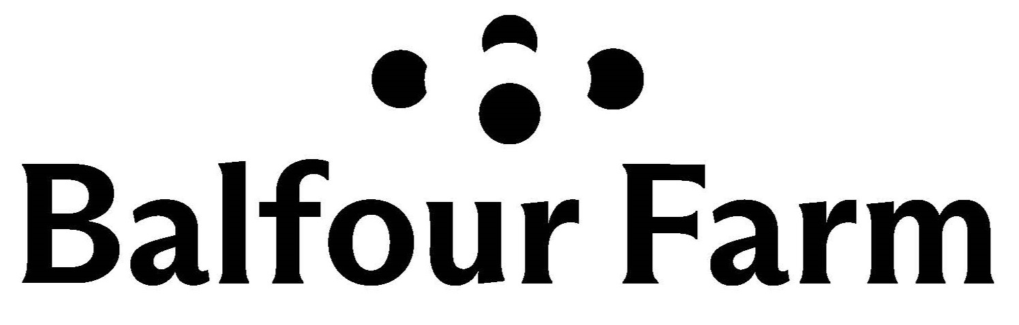

Balfour Farm LLC 461 Webb Rd. Pittsfield, ME 04967

www.balfourfarm.com balfourfarm@gmail.com (207)213-3159

Balfour Farm is a certified organic dairy farm with farmstead creamery producing raw milk cave aged cheeses, fresh cheeses and yogurts.

We expect all employees to exhibit a high standard of work ethic and prioritize taking care of the animals and working diligently with safety in mind.

**Position: Milking and General Farm Work**

* *Primary responsibilities:*
  + milking: we milk in the morning only. This shift begins at 7 am, but may be adjusted seasonally to start later in non-grazing months.
  + moving animals in the field, woods and barn areas, loading for transportation
  + feeding and watering all animals: pigs, chickens, cows
  + collecting, washing, sorting and packaging eggs
  + general farm work: mowing grass, cleaning pens, moving fencing, other duties as assigned
* *Desirable skills:*
  + exhibit safe operation of lawn mowers, string trimmers, week whackers, chainsaw, wood splitter, tractors with loader and buckets
  + attention to detail and ability to follow multi step directions
  + initiative to work- there is always something to do. There is no down time on a farm.
  + previous experience with large animals
  + take pride in your work and do it well, every time.
  + maintain a clean working area- put tools away where they belong, be mindful of sanitation and cleanliness of equipment, person and space
  + ability to monitor and notice changes from day to day- this includes working with animals and performance of equipment
* *Availability*: Employee will be available a minimum of 30 hours per week, including weekends. *Saturdays may be required for this position*. There will also be a few full weekends that will be scheduled in advance. In addition, the farm hosts at least two open houses each year, and more hours may be necessary on those days and leading up to the event.
* *Qualifications*:
  + Prior farm experience is preferred, but we are willing to train the right candidate
  + Demonstrates knowledge of basic farm tools and equipment
  + Time management skills
  + Effective communication skills
  + Must be a self starter and be able to work independently. Take pride in their work and be punctual. Team attitude is a must, and be willing to complete tasks to the best of their ability at all times.
  + Be willing to learn new skills and be able to follow multitask instructions.
  + Must have a clean drivers license and be 21+ years of age, and have reliable transportation
  + Education: HS diploma or equivalent
* Balfour Farm is a no smoking property. This is non- negotiable.

Complete Application at: [Balfour Farm Online Application](https://docs.google.com/forms/d/1ieIjVBrBpCCktRnT0rWVvgtUT9htyvl8ByWvBfoRU34/edit) or ask for a paper copy

Submit resumes to: balfourfarm@gmail.com or call Doug at (207)213-3158 with questions.