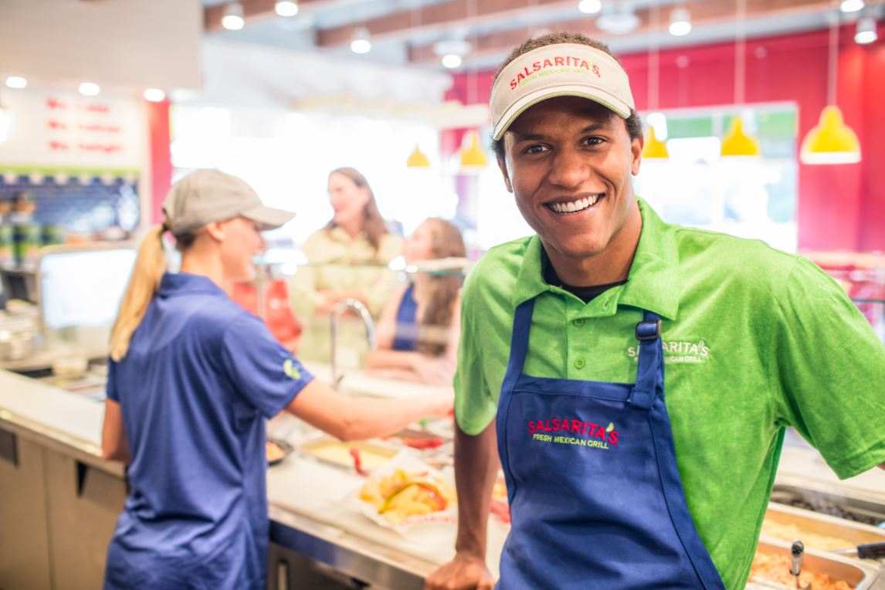
Shift Leaders

We are looking for friendly and motivated individuals with the desire to succeed. Shift Leads will be cross trained to work all parts of the operation. Everything from prepping and grilling, to serving customers on the line, running the register and administration. We provide training in all positions to get you on the path of a rewarding career. We are all about teamwork and helping each other out. We offer all shifts and flexible schedules. The ideal candidate will have top customer service skills and the ability to work in a fast-paced environment. If you are interested in a position that rewards your commitment and you have a friendly and outgoing personality, then we want you to become part of our Salsarita’s family!
Responsibilities
- Prep recipes
- Grilling and frying
- Chopping
- Serve Customers
- Cleaning and washing dishes
- Opening and closing the store
- Basic reconciliation of cash
- Daily Reports
- Customer service including handling customer issues
- Lead other employees
Requirements
- Have reliable transportation
- Be able to stand on your feet for 8-10 hours at a time
- 1 to 2 years restaurant experience
- Be able to work in a team environment
Benefits
- Competitive compensation package value of $13 - $17 per hour
- Meal plan
- Catering and in-store tip share
- Raise eligibility every 6 months
- Flexible schedule
- Paid breaks
- Health Insurance
- Opportunity for advancement
- Paid time off

For people craving a variety of tasty Mexican flavors, Salsarita's is the Fresh Mexican Grill that offers a bright and colorful atmosphere featuring signature Mexican dishes, house-made salsas, and seasoned tortilla chips and in a variety of sizes and catering options. Founded in 2000 in Charlotte, NC Salsarita's currently has over 80 locations in 19 states. For more information, please visit www.salsaritas.com.

