. 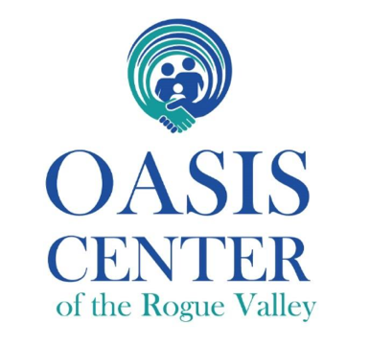
Position: Medical Director
Practice: Non-Profit Primary Care Clinic Focused on Substance Use Disorders
Compensation: 225,000-260,000/yearly, with sign-on bonus and potential for increased renumeration with part-time Medical Directorship with partner SUD residential agency
Location: Medford, Oregon
About Us
Oasis Center of the Rogue Valley (Oasis) is an innovative, non-profit, community-based primary care and addiction medicine practice that provides patient-centered treatment for families affected by substance use disorders. Our model is unique: we focus solely on families affected by substance use disorders in an on-going, primary care model. We provide services not found in other clinics: child watch, parenting classes and coaching, as well as employment services, legal counsel, and DHS Self-Sufficiency (SNAP, TANF) all under one roof. We provide truly holistic care, supporting patients in all aspects of their lives which impact health. Oasis is a rotation site for the Oregon Health Sciences University (OHSU) Addiction Medicine Fellowship, hosting 4 fellows a year. Additionally, Family Medicine residents from OHSU can electively rotate at Oasis, hosting 4-6 residents per year.
Oasis has a strong working partnership with Continuum Behavioral Health & Recovery Services, which provides both outpatient and residential SUD care. The successful applicant to Oasis would have the opportunity to become the Medical Director of Continuum, with enhanced remuneration and the ability to provide streamlined medical-behavioral health between agencies. Currently, a partnership between Oasis and Continuum coordinates a cutting-edge pre-engagement, low-barrier, housing model to facilitate those in active substance use in their journey to recovery. Future opportunities may include merger discussions with Continuum to seamlessly integrate all aspects of patient care, including residential treatment and childcare.
Opportunity
We’re seeking an experienced and mission-driven medical professional to guide our clinical team and advance our innovative, family-focused approach to addiction and primary care. The ideal candidate is a clinician-leader who values collaboration, relationship-based medicine, and recovery-oriented systems of care.

Responsibilities
- Provide clinical leadership, supervision, and mentorship to an interdisciplinary team (medical, behavioral health, and recovery peer support).
- Deliver direct outpatient care in family medicine and addiction medicine, including MOUD and co-occurring disorder management.
- Oversee quality improvement, compliance, and program development.
- Collaborate with community partners and participate in advocacy and education initiatives supporting family-centered recovery.

Qualifications
- MD or DO, board-certified in Family Medicine; Addiction Medicine certification (ABAM/ABPM) strongly preferred.
- Active and unrestricted medical license in the state of Oregon (or ability to obtain).
- Minimum 3–5 years of experience in primary care, addiction medicine, or integrated behavioral health.
- Proven leadership ability and enthusiasm for team-based, trauma-informed, harm-reduction care.

Compensation & Benefits
- Very competitive salary with signing bonus and 2-year salary guarantee.
- Comprehensive benefits and 6 weeks paid time off in addition to holidays.
- Eligible for NHSC or state loan repayment programs.
- Flexible scheduling and supportive, collegial environment.

How to Apply
Please email your CV and a brief cover letter describing your interest in family-centered addiction medicine to kristenj@oasiscenterroguevalley.org. Applications reviewed on a rolling basis until the position is filled.

The Oasis Center of the Rogue Valley — more than a clinic, a community

