Manassas Park is an independent jurisdiction in Northern Virginia, approximately 30 miles southwest of Washington, DC. The city borders Prince William County and the City of Manassas. Manassas Park offers citizens an established community along with the prospects of significant future residential and commercial development. The desirable living features such as neighborliness and community pride in a small, progressive city environment add to the City’s charm.

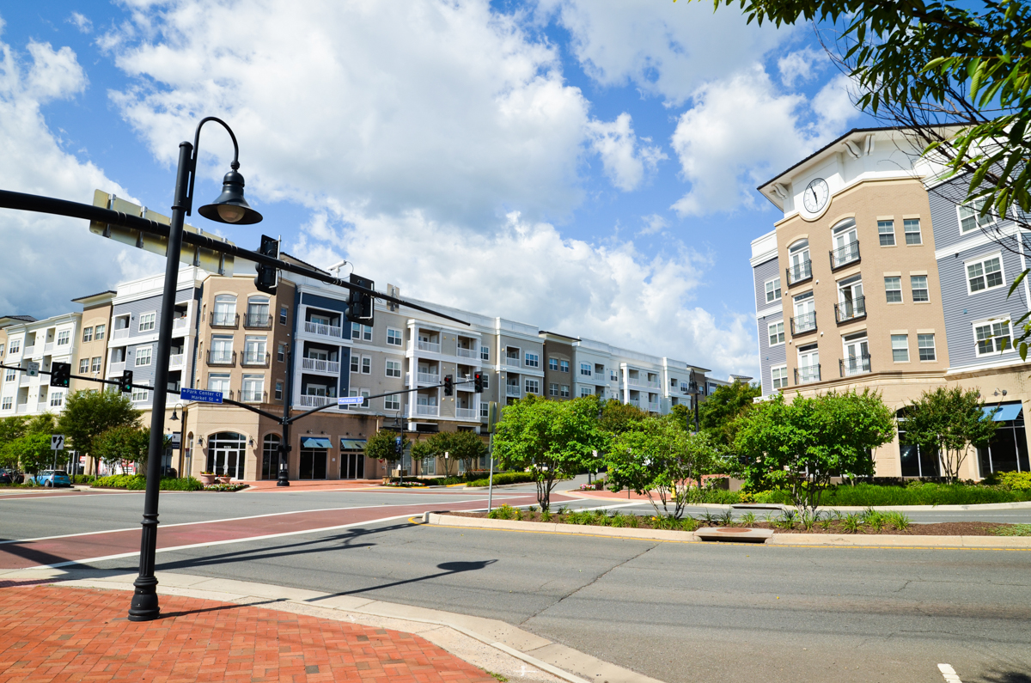

The City of Manassas Park is seeking an experienced Aquatics & Operations Manager. The Aquatics & Operations Manager assists the Parks and Recreation Director in administering the day-to-day operation of the Manassas Park Community Center and provides daily oversight and command of all aquatic facilities, programs, and aquatic personnel. This individual will develop and implement department policies and objectives that maximize operational efficiency and will work with department staff to coordinate and facilitate department wide EAP and SOP trainings. The Aquatics & Operations Manager will possess a professional and comprehensive knowledge of facility management, business process, facility maintenance, pool management, principles and methods of water rescue, general aquatics programming, and will be skilled in dealing with the public. This position will oversee the Operations, Aquatics, and Custodial divisions, serve as the department’s representative on the City Safety Committee, and coordinate CPR/First Aid training for department staff.

All positions at the City of Manassas Park require a customer service mindset, in accordance with the Customer Service-related focus of the City.

Specific Duties and Responsibilities

- Direct facility operations and develop a comprehensive maintenance plan that ensures cost effective, efficient, and functional workflow. Maintain customer satisfaction by providing a safe, clean, secure and aesthetically pleasing environment. Develop and enforce facility rules and regulations. Coordinate with the Maintenance Supervisor to initiate and complete facility repairs according to policy and procedure and ensure regularly scheduled safety checks are performed and documented. Work with outside vendors to identify and address facility maintenance needs and document completion of required work/repairs, per the department’s work order tracking software.
- Oversee the purchase and coordination of equipment and contracted services; review specifications, document procurements via the department’s internal expenditure tracker, and confirm accuracy and timeliness of work, both in-house and via outside contractors.
- Ensure patron injury and city incident/accident reports are submitted on time, accurately completed, and executed according to policy. Audit and schedule CPR & First Aid certifications for all staff; maintain staff roster.
- Manage aquatic facility operations and maintenance plans, both at the Manassas Park Community Center and signal Bay Water Park, to ensure consistent and effective service delivery, as well as provide a safe, sanitary, and welcoming environment. Develop and schedule a variety of aquatic programming options to include classes, swim meets, swim lessons, lap swimming, youth swim leagues, etc. Manage aquatic staff training for water safety, CPR, and first aid; ensure all aquatic certifications are maintained and up to date; schedule/coordinate regular, routine in-service trainings for aquatics staff. Manage ongoing inventory of operating equipment, chemicals, uniforms, cleaning solution, and first aid supplies.

- Secure and coordinate lane rental requests in order to maintain a careful balance of pool usage among multiple user groups, ensuring equitable access to space for internal programming (swim lessons), rental groups (swim teams), training (swim team and LG classes), and daily patron use (lap swimmers).
- Oversee full-and part-time staffing levels in the Operations, Aquatics, and Custodial divisions. Create staff schedules, review bi-weekly payroll for support staff, and monitor leave requests. Conduct staff meetings; create and deliver presentations to elected officials, senior management, staff, and other public or private agencies or groups. Participate in department/city committees, as assigned.
- Formulate budget line proposals for the Operations, Aquatics, and Custodial divisions. Provide oversight of designated budget lines. Monitor expenses, revenue, and program fees. Use fiscal prudence and discretion when planning/executing purchases and complete expenditure tracking spreadsheet in real time; ensure support staff follow financial protocols; routinely audit expenditure tracker accuracy for respective division lines. Provide predetermined operational and aquatics-based data to the Director and Administrative Manager on a monthly basis; provide other division data, statistics, and metrics on an as-needed basis.
- Oversee rental set-up, response, and tear down. Work in conjunction with the customer Service and Custodial divisions to implement processes that protect the integrity of the space, while also ensuring positive rental experiences for the customer.
- Ensure facility furniture and equipment is safe, functional, and in proper working order. Facilitate remediation efforts; secure/install new items when necessary. Manage inventory and develop procurement schedule based on lifecycle projections.
- Regularly inspect community center and aquatic facilities for potential safety or maintenance concerns; implement corrective measures to mitigate safety hazards or mechanical breakdowns. Support Department Director with capital project research, planning, and implementation. Coordinate and oversee department’s annual shutdown week.

- Manage staff performance in accordance with the City’s Employment Policies and Practices Manual and the DPR Personnel Manual. Conduct the following HR functions with direct reports: guidance/support, performance evaluation, improvement plan discussion and recommendation, disciplinary action, schedule adjustments, job orientation and expectations, and conflict resolution. Initiate recruitment, conduct interviews, and execute new hire paperwork. Maintain staff records, documentation, and reports.
- Establish and maintain business systems that provide for an efficient, effective, and responsive operation.
- Prepare signal Bay Water Park for opening each year. Tasks include draining/cleaning both the activity pool and lazy river, sanding, painting, power washing, conducting/scheduling necessary repair work, assembling play features, de-winterizing filter system and bathhouse, and ensuring the pool’s filer system is withing health department standards.
- Winterize Signal Bay Water Park at the conclusion of each season. Tasks include dropping water levels, blowing out filtration lines, applying anti-freeze, moving/stacking/repairing deck furniture, disassembling play features, applying chemical treatment to Lazy River, and turning off freshwater lines.
- Oversee the seasonal startup and winterization of the City Hall Splashpad. Coordinate the daily maintenance during the operating season, to include troubleshooting chemical readings/pump issues, performing minor repairs, and coordinating with contractors to facilitate larger-scale repairs.
- Coordinate/communicate with the Facilities Manager (General Services Department) on preventive and corrective maintenance tasks, along with capital improvement projects related to the city’s Mason and Partners Clinic (MAP) and Stone House.
- Coordinate day care and large group reservations at Signal Bay Water Park; oversee the birthday party package process.
- Manage Signal Bay Water Park’s daily deposit process; ensure all applicable support staff have been properly trained in the department’s cash handling policies and procedures.
- In addition to the above-mentioned job responsibilities, all positions at the City of Manassas Park are expected to promote a culture of civility, where respectful engagement, open communication, and collaboration are standard practices. These skills and expectations are equally important as the functional requirements of this position.

Knowledge, Skills and Abilities Required

- Knowledge of the principles, practices, and procedures of facility operations, recreation planning, and programming.
- Knowledge of community organizations and human service agencies related to the field of recreation.
- Knowledge of pool, fitness, and fee-based recreation programming.
- Knowledge of facility specific building and pool systems.
- Ability to plan, implement, and evaluate operations with an emphasis on revenue generation.
- Knowledge of department policies and procedures.
- Knowledge of first aid methods and safety precautions.
- Ability to maintain order in a public center.
- Knowledge of word processing and other database programs.
- Ability to supervise and evaluate the work of others, including performance management.
- Ability to effectively communicate ideas clearly and concisely in both written and verbal form.
- Ability to establish and maintain effective working relationships with fellow employees, volunteers, and the general public.

Minimum Education and Training

- BS Degree from an accredited college/university, with major work in Recreation & Leisure Services, Operations Management, Athletic Administration, Business Administration, or related field is preferred.
- Experience in facility management.
- Experience managing aquatic facilities and programs.
- Certified Pool Operator Certification, Water Safety Instructor, Lifeguard, and Lifeguard Instructor certifications required.
- Experience developing and implementing aquatic programs and activities.
- Experience working with the public, contractors, vendors, and outside organizations; at least two years’ experience in a supervisor/leadership role.
- Or an equivalent combination of education, training, and experience.

ADA Compliance

The City of Manassas Park is an Equal Opportunity Employer. In compliance with the Americans with Disabilities Act, the City of Manassas Park will provide reasonable accommodations to qualified individuals with disabilities and encourages both prospective and current employees to discuss potential accommodations with the employer.

- Work requires standing or walking some of the time, exerting 20 to 50 pounds of force on a regular basis, and considerable dexterity and skill in operating machinery, tools, or equipment. Work also requires the ability to work a highly flexible schedule, which may include early morning, nights, days and weekends and the performance of manual and mechanical work under adverse conditions.
- May occasionally be called back to work to provide staff coverage to assist with a facility emergency. On-call and/or subject-to-call city. In city emergencies, subject to recall.
- The position is exposed to extreme heat/cold, wet or humid conditions, bright/dim lights, dust or pollen, intense noise levels, vibration, fumes or noxious odors, moving mechanical parts, electrical shock, heights, and toxic or caustic chemicals.

Authorized Hiring Range: $77,000 - $90,000

If you are interested in becoming a member of our team, you must complete an application form and submit a resume and cover letter to the City of Manassas Park, Human Resources Department, 100 Park Central Plaza, Manassas Park, VA 20111 or fax/email: 703-335-0053 / humanresources@manassasparkva.gov

You may obtain an employment application by going to the following link:
https://manassaspark.rja.revize.com/forms/3556

Application Deadline: September 19, 2025

The City of Manassas Park is committed to ensuring diversity in its workplace, and candidates from diverse backgrounds are strongly encouraged to apply.

