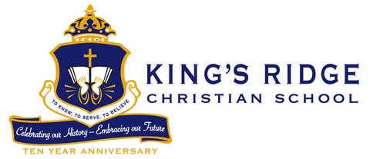

Lower School Teacher

Job Title: Lower School Teacher | Status: 10 Month Full-time/Exempt
Date: | Reports to: Head of Lower School

Summary
Fulltime ten (10) month position to teach lower school grade level. The role’s primary purpose is to create an elementary grade program and classroom environment favorable to learning and personal growth that supports the mission and vision of the school. A Lower School Teacher establishes effective rapport with students where they feel known, supported and feel free take risks in their learning while motivating students to develop the skills, attitudes and knowledge needed to develop a strong foundation. Also required to establish healthy, professional relationships with parents and other staff members.

Essential Functions
The tasks, duties, and responsibilities of this job include, but are not limited to:

- Teaching reading, language arts, social studies, mathematics, and science to students in a classroom utilizing a course of study provided by the school.
- Instructing students in Christ-like behavior and overall citizenship.
- Developing lesson plans and instructional materials that include individualized and small group instruction in order to adapt the curriculum to the needs of each student.
- Using a variety of instruction strategies, such as inquiry, group discussion, lecture, discovery, etc.
- Using technology to expand, differentiate and enhance learning.
- Translating lesson plans into learning experiences so as to best utilize the available time for instruction.
- Establishing and maintaining a standard of student behavior needed to achieve a functional learning atmosphere in the classroom.
- Communicating with parents through conferences and other means to discuss students’ progress and interpret the school program.
- Identifying student needs and cooperating with other professional staff members in assessing and helping students solve health, attitude, and learning problems.
- Creating an effective environment for learning through functional and attractive displays, bulletin boards, and interest centers.
- Being a lifelong learner by attending professional growth activities, continuing to read professional texts, and taking advantage of online learning.
- Participating cooperatively with the school leaders to develop a program that meets the guidelines of the school.
- Selecting books and instructional aids.
- Maintaining required inventory records and anecdotal notes.
- Supervising students throughout the school day.
- Administering group standardized tests in accordance with testing program.
- Participating in curriculum development programs as required.
- Working collaboratively with colleagues and maintaining a positive upbeat spirit.

Qualifications
Education

- Bachelor’s degree of related subject from accredited university
Experience
- Experience is preferred but not necessary for hiring
Other
- Teaching certificate
- Knowledge and experience in the teaching of Reading Workshop approach preferred
- Ability to serve in a 12-month role

Physical Requirements
In compliance with ADA requirements, we will make reasonable accommodations for the known disability of an otherwise qualified applicant.

Additional Responsibilities
The statements in this job description are intended to represent the key duties, essential nature and level of work being performed. They are not intended to be all responsibilities or qualifications of the job.

All employees are expected to possess a strong Christian commitment, support the mission, vision and faith statements of King’s Ridge Christian School, and to contribute to the overall life of the school.

King’s Ridge Christian School is a Christian community providing a college preparatory education equipping students to know, to serve, and to believe.

For more information and to submit an application/resume online:
Please visit our KRCS Careers page at:
http://www.kingsridgecs.org/about-us/careers

