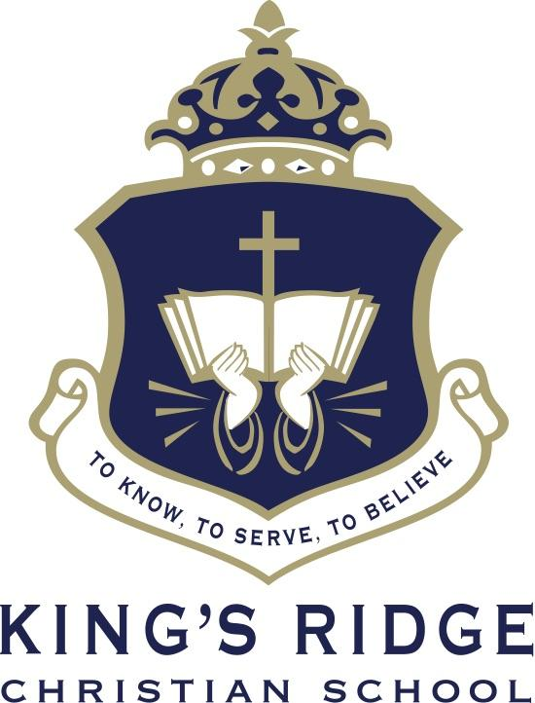

Middle School English Teacher

Job Title: Middle School English Teacher  Date: 2026 | Status: 10 Month Fulltime/Exempt  Reports to: Head of Middle School

Summary
Fulltime ten (10) month position teaching Middle School English to 5th and 6th grade students. The teacher’s main role is to create a stimulating learning environment in which every child is expected to reach their own academic potential while being nurtured with Christian values.

Essential Functions
Classroom Teaching
- Makes students feel known, nurtured, loved, and valued as individuals.
- Makes students believe that you are an advocate committed to their success.
- Requires developmentally appropriate higher-order thinking skills.
- Classroom instruction is organized and well-prepared with a clear objective.
- Creates a learning environment in which students participate and are engaged.
- Maintains an orderly classroom environment conducive to learning.
- Accurately assesses each student’s level of achievement.
- Demonstrates mastery of subject matter.
- Effectively uses technology to enhance teaching and learning of the subject material.
- Establishes a rapport with students so that they are comfortable interacting with teacher on academic or behavioral matters.
- Sets, communicates, and consistently holds students accountable to developmentally appropriate behavior consistent within a Christian community.
- Grades and returns assignments in a timely fashion.
Administrative
- Makes parents feel their child is known as an individual.
- Keeps relationships with parents on a professional level.
- Communicates student success.
- Communicates effectively both verbally and in writing with parents.
Advisor/Small Group
- Takes leadership over a group of 8-12 students.
- Takes an active interest in the lives of advisees.
- Keeps in close contact with advisees’ parents and teachers.
- Takes responsibility for advising in all aspects of school life – academics, co-curricular activities, socially, emotionally, ethically, spiritually.
- Leads/Facilitates small group discussions on spiritual topics.
- Attends chapel and incorporates chapel topics into group discussions.

Spiritual
- Is in a growing relationship with Jesus Christ.
- Provides a faith integrated educational environment.
- Takes responsibility for being a spiritual role model and leader for students.
- Obeys Christ by maintaining a demeanor of Christian ethics and integrity.
- Consistently strives to exhibit Christian behavior in all aspects of one’s life.

Qualifications

- Bachelor's degree (B. A.) from four-year college or university required. Advanced degrees and 2-4 years’ experience desired. Additional requirements as applicable under the SAIS.
- Ability to effectively present information and respond to questions from groups of students, parents, faculty, staff, and administrators.
- Carry out supervisory responsibilities in accordance with the schools’ policies and applicable laws. Responsibilities include planning, assigning, and directing work; appraising performance; rewarding and disciplining students; addressing complaints and resolving problems.

Physical Requirements
In compliance with ADA requirements, we will make reasonable accommodations for the known disability of an otherwise qualified applicant.

Additional Responsibilities & Information
The statements in this job description are intended to represent the key duties, essential nature and level of work being performed. They are not intended to be all responsibilities or qualifications of the job. Current background check and drug screen will be required for employment.

