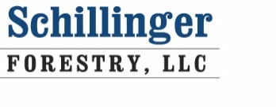
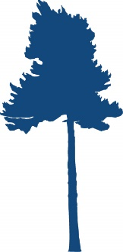

1826 PERRY’S LOOP

TRAVERSE CITY MI, 49685
WWW.MICHIGANFORESTER.NET

Schillinger Forestry is seeking a highly motivated and dependable Forester to join our team based in Traverse City Michigan. Interested individuals should submit cover letter, resume and an example of a Forest Management Plan to: Daniel Schillinger at the address above or via e-mail; schillingerforestry@gmail.com

Wage and benefit package will be commensurate with candidate’s experience/education and will exceed comparable public sector compensation. Employees will be encouraged to grow professionally throughout their employment. Position open until filled.

Applicant Requirements;
- Bachelors of Science in Forestry from a SAF accredited university (applicants whom have completed through junior year and are finishing their senior year will also be considered)
- Excellent communication skills; telephone, writing, public speaking
- Computer literacy including these applications; Access, Word, Excel, Outlook, etc.
- Excellent navigational skills using; compass, aerial photography, topography and soils maps
- A valid driver’s license and an ability to remain drug and alcohol free during work hours
- A willingness to grow and expand their efficiency, effectiveness and expertise in Forestry

Employee Requirements (must be maintained or applied for shortly after hiring)
- Commercial Pesticide Applier in Forestry (2), Ornamental (3B), and Right of Way (6)
- Certified Arborist & TRAQ Certified Arborist
- Michigan Registered Forester
- Association of Consulting Forester and/or Society of American Foresters Membership

Position Duties, in order of time spent
- Ornamental Urban Tree Care; Spraying for targeted insect and diseases, trunk injecting trees for the same and fertilizing to overcome site specific problems (tree care truck and application equipment will be provided for employee’s use)
- Marking timber for commercial timber sales on private land
- Timber sale administration
- Forest inventories for management plans and timber valuation
- Marking timber sale boundaries inside of surveyed property lines
- Urban tree pest and disease diagnosis – Hazard Tree Inventories
- Forestry client growth and development
- Invasive plant species identification and control

Workday requirement notes: The employee’s urban tree care work day begins extremely early to avoid disturbing clients when people are outside. Most of the forestry work involves being outside all day often climbing steep terrain through woods where there are branches/trees and deep snow on the ground which increase the possibility of tripping or slipping. Both tasks require the employee to be on their feet all day and still be able to perform their duties; pull a 300’ long hose to spray or fertilize, carry up to 5 gallons of fertilizer, mark trees carrying 2-3 gallons of paint and accurately measure trees for management plan data collection.

