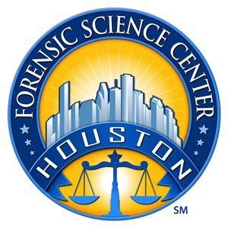
Houston Forensic Science Center, Inc.

EXPERIENCED FIREARMS EXAMINER
Houston Forensic Science Center, Inc. (HFSC), is an independent organization created by Houston Mayor Annise Parker and the Houston City Council to provide forensic science services formerly delivered by the Houston Police Department. HFSC has been officially registered as a Texas Local Government Corporation* since June 26, 2012.

Houston Forensic Science Center is seeking a full-time, experienced Firearms Examiner.

POSITION SUMMARY
The primary job duties of the Firearms Examiner are to examine and interpret firearms evidence associated with alleged criminal acts. Specific duties of the Firearms Examiner may include, but not be limited to performing the following duties with little or no direct supervision:
- Examination and test firing of firearms.
- Comparisons of fired bullets and cartridge cases. HFSC is currently in the process of validating the use of 3D technology/VCM for use in casework.
- Acting as a second/verifying examiner on cases completed by other examiners.
- Conducting administrative and technical reviews of case records.
- Testifying in courts of law regarding analyses performed.
- Entering specimens into NIBIN and reviewing correlations.
- Note: HFSC conducts limited serial number restoration cases. HFSC does not do distance determination or toolmark testing.

MINIMUM EDUCATIONAL REQUIREMENTS
- The position requires a minimum of a bachelor’s degree in a physical science (Chemistry or Biology, etc.) or Forensic science from an accredited university (transcripts required).
MINIMUM EXPERIENCE REQUIREMENTS
Direct working experience as a Firearms Examiner in a Forensic Lab environment is required.
- Prior successful completion of a formal training program for firearms examination in an accredited laboratory is required.
- A minimum of two years of examiner experience as a primary examiner (after the training) in an accredited laboratory is strongly preferred.

KNOWLEDGE AND SKILL REQUIREMENTS
Successful candidates will be able to demonstrate:
- Thorough of firearms examination practices and procedures.
- Familiarity with ISO-17020 or ISO-17025 accreditation standards.
- Well-developed oral and written communication skills.
- Ability to maintain strong professional relationships with customers and internal team members.
- Intermediate computer literacy and familiarity with common software applications.
- Strong analytical, critical thinking, and decision-making skills with attention to detail.
- Effective time and task management with adaptability to fluctuating priorities.

CONTACT INFORMATION

Houston Forensic Science Center, Inc. is an Equal Employment Opportunity Employer
*A “local government corporation” is created to aid and act on behalf of one or more local governments to accomplish any governmental purpose of those governments.

