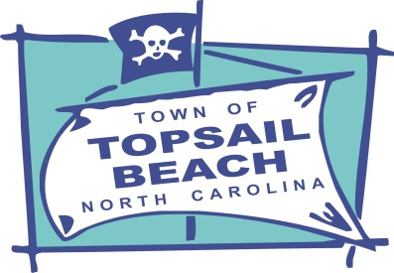

**Job Title:** Public Works Specialist

**Salary Range:** $42,441 to $65,784

**Expected Hiring Range:** $42,441 to $50,000  
**Hiring Salary:** Based on Qualifications

**Appointment Type:** Regular, Full-Time

The Town of Topsail Beach Public Works Department is accepting applications for the position of Public Works Specialist. As a Public Works Specialist, you will play a vital role in keeping Topsail Beach a clean, safe, and beautiful place for residents and visitors alike. An employee in this position maintains and cleans public grounds and facilities as well as performs landscape maintenance including mowing, trimming, and related tasks. Ensures the cleanliness of the town and beach; picks up litter from streets, sidewalk, and beach areas; removes unpermitted cabanas and discarded items from the beach. Operates equipment such as lawn mowers, dump trucks, loaders and a variety of hand and power tools as well as cleaning, washing, preventive maintenance and minor repairs to equipment. Work also includes assisting with beach access maintenance and repair which may include carpentry work, asphalt repair, and installation and maintenance of informational and street signs. In addition, the employee participates in the maintenance and repair of the water distribution system. An employee in this position is subject to working some weekends in an on-call rotation, in both inside and outside environments, exposure to various hazards such as loud noises, moving mechanical parts, chemicals, fumes, and oils. Work is performed under regular supervision of the Public Works Superintendent. If you enjoy being part of a supportive team, working outdoors, taking pride in keeping spaces clean and well-maintained, and thrive in a hands-on environment, we encourage you to apply!

**Knowledge, Skills and Ability Requirements:**Working knowledge of grounds and landscape maintenance methods as well as basic construction and carpentry. Skill in the use and care of assigned tools and equipment.   
Capable of performing heavy manual labor as necessitated by work assignments.  
Possess the ability to work cooperatively as a team member and respond courteously to citizens.  
  
**Desirable Education and Experience:**

Graduation from high school and some experience in landscape maintenance and/or construction work; or an equivalent combination of education and experience.  
  
**Special Requirement:**Possession of a valid North Carolina driver's license. Any NC water, wastewater, or pesticide certifications are desirable but not required.

**Compensation and Benefits:**

The Town provides a comprehensive benefits package including health, dental, vision, and life insurance; Local Government Employees Retirement System (LGERS) contribution; annual vacation and sick leave; paid holidays.  
  
**Submittal Information:**

To apply, please complete the online application:

<https://topsailbeachnc.gov/Government/Employment-Opportunities>

Deadline: **August 17, 2025**

Topsail Beach is an Equal Opportunity Employer.