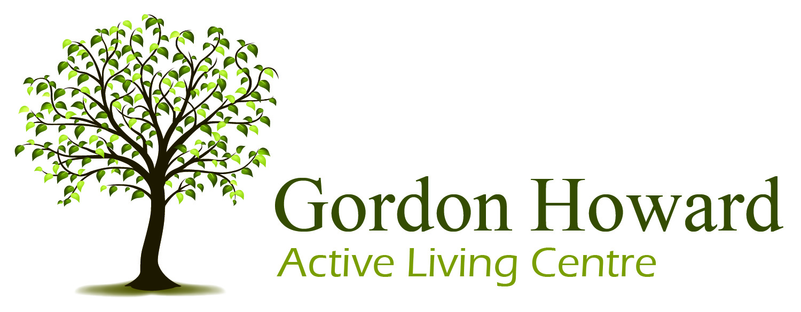

Executive Director

Gordon Howard Active Living Centre

(Selkirk, Manitoba)

Welcome to a life full of energy, connection, and possibility!
The Gordon Howard Active Living Centre is a vibrant non-profit community hub in downtown Selkirk, Manitoba serving adults in Selkirk, St. Andrews, and St. Clements. We’re dedicated to supporting lifelong wellness—physically, mentally, and socially—and we’re looking for an inspiring Executive Director to lead our team into exciting future.

About the Role
Reporting directly to the Board of Directors, the Executive Director provides strategic and operational leadership across five key areas:
- Board relations and governance
- Financial management and budgeting
- Staff and volunteer leadership
- Community and stakeholder relations
- Program and facility operations
Qualifications
- Post-secondary education in business, public administration, social science, recreation management, aging adults.
- Proficiency in Microsoft Excel including data entry, formula usage and analysis.
- Experience with the broader Microsoft 365 Environment, including Word, PowerPoint, OneDrive and SharePoint.
- Knowledge of issues affecting aging adults.
- Fundraising, marketing and public relations experience.
- Self-motivated and able to work independently.
Preferred
- 3+ years in the non-profit sector

Conditions of Employment
A Satisfactory Criminal Record Check with Vulnerable Sector Search as well as a Satisfactory Adult Abuse Registry Check must be provided.

Apply by January 30, 2026
A full job description is available at www.gordonhoward.ca
Email your résumé or inquiries to
director@gordonhoward.ca

Gordon Howard thanks all applicants for their interest, however only those selected for an interview will be contacted.

