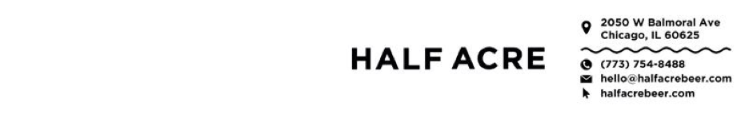

POSITION TITLE

Lead Maintenance Technician

JOB SUMMARY:

The Lead Maintenance Technician at Half Acre Beer Co. is a hands-on technical role responsible for maintaining, troubleshooting, repairing, and improving brewery production and facility equipment, with a strong emphasis on maintenance system continuity, responsive service to internal customers, and accurate CMMS data.

DUTIES/RESPONSIBILITIES:

Safety & Standards
- Lead by example in adherence to Half Acre safety policies, OSHA requirements, and Good Manufacturing Practices (GMPs).
- Actively participate in continuous improvement initiatives.

Hands-On Maintenance & Troubleshooting
- Maintain, troubleshoot, and repair brewery production equipment, including high-speed beverage packaging systems such as can fillers, double seamer, keg-wash/fill line, and brewhouse systems.
- Support utilities and facilities systems including glycol chillers, boilers, HVAC equipment, compressors, pumps, gearboxes, and kitchen equipment.
- Perform mechanical work including alignment, lubrication, disassembly/reassembly, pump rebuilding, and seal replacement.
- Troubleshoot and maintain mechanical, electrical, pneumatic, and hydraulic systems.
- Serve as an on-floor subject matter expert for production equipment and complex repairs.

CMMS Data Integrity & Maintenance System Development
- Act as the primary day-to-day steward of CMMS data quality and usability, in coordination with the Facilities Manager.
- Develop, maintain, and continuously improve preventive maintenance tasks and schedules.
- Create clear, step-by-step PM and job plans for routine, complex, and infrequent repairs.
- Maintain accurate asset records, equipment histories, and asset relationships.
- Maintain parts lists and spare components associated with specific assets.
- Ensure maintenance documentation reflects actual work practices and supports repeatability.
- Identify gaps, redundancies, or unclear procedures and collaborate with management to address them.
- Support broader documentation efforts using CMMS, SharePoint, and Microsoft Teams.

Training & Technical Leadership
- Assist in training and onboarding maintenance technicians on equipment, procedures, and CMMS standards.
- Review PM execution quality and provide coaching on troubleshooting approaches and repair best practices.
- Act as the technical decision-maker during maintenance activities when the Facilities Manager is not present.
- Support autonomous maintenance initiatives and collaboration with production teams.

Vendor, Contractor & OEM Coordination
- Serve as the primary technical point of contact for external vendors, contractors, and equipment manufacturers.
- Coordinate service visits, troubleshooting calls, and equipment repairs.
- Maintain service documentation, OEM manuals, and repair history.
- Assist with parts sourcing and recommendations for critical spares.

Continuous Improvement & Accountability
- Identify root causes of equipment failures and support implementation of long-term corrective actions.
- Contribute to maintenance KPIs, reliability goals, and production uptime.
- Maintain a clean, organized, and professional work environment.
- Document work clearly and communicate effectively with production and leadership teams.
- Other Duties as assigned.

REQUIRED SKILLS/ABILITIES:
- Must be 21+ years old.
- Strong mechanical and electrical troubleshooting skills.
- Ability to read and interpret blueprints, schematics, and equipment manuals.
- Experience working within a CMMS and contributing to accurate documentation and PM development.
- Ability to balance hands-on maintenance work with documentation and system improvement.
- Strong communication skills and ability to train and guide other technicians.
- PLC familiarity (Siemens or Allen-Bradley) preferred.

BENEFICIAL EXPERIENCE:
- High school diploma or equivalent.
- 3+ years of maintenance experience in a beverage production or manufacturing environment.
- Prior experience maintaining high-speed beverage packaging equipment or similar food/manufacturing systems.
- Experience with automated fillers, seamers, keg lines, and brewhouse systems (or equivalent equipment).
- Technical certifications.
- Ability to weld.
- PLC Troubleshooting.

PHYSICAL REQUIREMENTS:
- Ability to ascend/descend stairs and ladders and work at varying heights and angles
- Ability to lift and transport loads up to 65 lbs and maneuver heavy equipment with assistance
- Ability to perform desk work for documentation and CMMS updates
- Comfortable working in hot, cold, wet, noisy indoor and outdoor environments
- Ability to stoop, kneel, crouch, and work under/around conveyors and equipment
- Close vision, distance vision, peripheral vision, depth perception, the ability to adjust focus and the ability to see color; either with or without accommodation.

