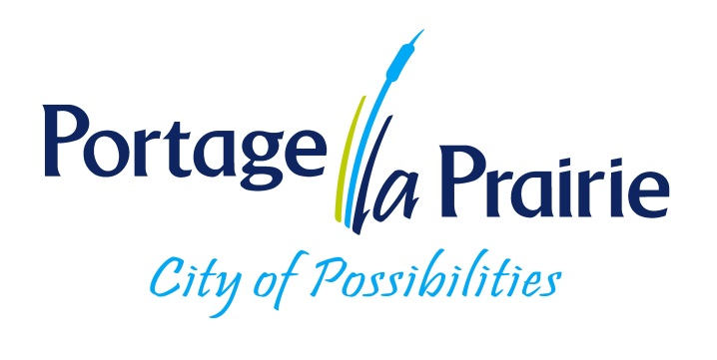

***City of Portage La Prairie***

**Class 4 Water Treatment Operator**

**Posting # 2025-12**

Under the direction of the Water Treatment Supervisor, the operator ensures the safe and effective monitoring and operations of processes and equipment for the water treatment division and acts as operator in charge as required.

MANDATORY QUALIFICATIONS: The City of Portage la Prairie is a Class IV facility and a Class 4 Certificate in Water Treatment is required. Each level of certification requires a specific exam, level of education, operating experience and DRC time. The successful candidate must hold and maintain a Class 5 Province of Manitoba driver’s license. This position requires operators to work at heights and in confined spaces.

Criteria needed to obtain a Class 4 Certificate in Water Treatment:

* Grade 12

* 4 years post-secondary education in a science related field

* 4 years operating experience with 2 year of DRC time (Direct responsible charge)

* Passed all certification exams (Class 1 to Class 4)

Applicants with a minimum 2 years post-secondary education or 90 CEU in a related field may be considered on an under-fill basis. Required certifications to be obtained within specific time frame as per the guidelines outlined in the collective agreement.

For more information on the requirements needed to achieve a Province of MB Class 4 Certification please visit <http://www.gov.mb.ca/sd/eal/certification/info_cert.pdf>

HOURS OF WORK: 7:30 am to 4:30 pm, 1 hour for lunch, Monday to Friday. Required to work one weekend per month and be on standby one week a month. (Shifts may be changed due to operational requirements). Employees on standby duties are required to carry a pager must be able to report to work within thirty minutes period.

SALARY: CLASS IV: $38.90 per hour as per CUPE collective agreement. The rate of pay for an underfill ranges from $26.65 to $36.31 dependent of education, experience and certification levels.

Please forward applications to Human Resources Office, City of Portage la Prairie, 97 Saskatchewan Ave East, Portage la Prairie, MB, R1N 0L8, FAX (204) 239-1532.

Email Address: [hr@city-plap.com](mailto:hr@city-plap.com). Website: [www.city-plap.com](http://www.city-plap.com)

Applications must be received by 4:30pm Friday September 12th, 2025 and marked

Posting “2025-12” however, applications may continue to be accepted until the right candidate is found.

The City of Portage la Prairie is committed to an inclusive, barrier free environment and will accommodate the needs of applicants under the Accessibility for Manitobans Act (AMA) throughout all stages of the recruitment and selection process. We thank all applicants for their interest; only those advancing in the competition will be contacted. If contacted to participate in the process, please advise if you require an accommodation.

***We thank all applicants for applying; however, only those being considered for an interview will be contacted.***