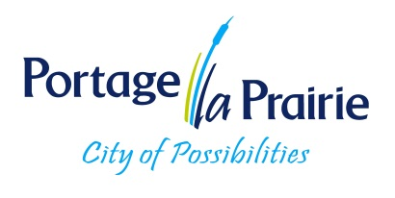
City of Portage la Prairie
Water Treatment Operator
Our water treatment plant is expanding, and we want you to join our team.
Have you ever thought of pursuing a career in water treatment? There are many benefits of working in this field, including career stability, teamwork, having a meaningful impact on your community, diverse opportunities, continuous education, and a great variety of work. Water Treatment Operators play a vital role in maintaining public and environmental health within the region. Water treatment professionals have the crucial task of guaranteeing the consistent operation of systems, effective treatment of potable water, and preventing any negative impact on the health of our local ecosystems.
The City of Portage la Prairie has an immediate opening for permanent full-time (40 hours per week) Water Treatment Operator. The successful applicant will have a valid MB class 5 driver's license, a grade 12 education or GED and a minimum of 2 years post-secondary education in the Sciences, Civil Engineering Technology, Environmental Studies, or related fields. The ideal candidate will be physically fit, have excellent mechanical aptitude and a commitment to continued education to obtain class 4 water treatment certification.
The City of Portage la Prairie offers a comprehensive benefit package and pension plan. Compensation is outline in our CUPE collective agreement and is dependent upon qualifications, experience, and certification.
To apply, please submit your cover letter and resume to careers@city-plap.com and marked Competition #2026-06. This position will remain open until filled.
For more information on the requirements needed to achieve a Province of MB Class 4 certification please visit http://www.gov.mb.ca/sd/eal/certification/info_cert.pdf.
For a detailed job description please view Operator WTP Class 4 Job Description.
We thank all applicants for applying; however, only those being considered for an interview will be contacted
The City of Portage la Prairie is committed to an inclusive, barrier-free environment and will accommodate the needs of applicants under the Accessibility for Manitobans Act (AMA) throughout all stages of the recruitment and selection process. We thank all applicants for their interest; only those advancing in the competition will be contacted. If contacted to participate in the process, please advise if you require an accommodation.

