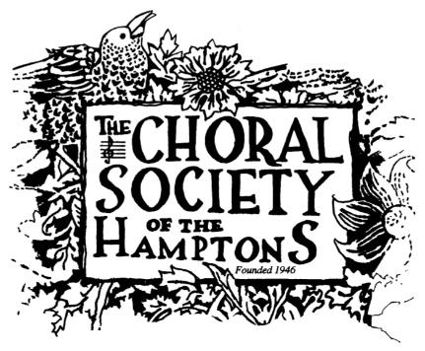

Job Description - ADMINISTRATIVE DIRECTOR

General Description
The Administrative Director for the Choral Society of the Hamptons acts as a coordinator for all activities for this local not for profit community chorus founded in 1946. Activities include producing three concerts/year, maintaining a membership database, assisting with the creation and tracking of an annual budget of $130,000, assisting with fundraising events and mailings and serving as point person for most inquiries and speaking on behalf of the organization. The Administrative Director is a part-time position expected to work an average of 10 hours/week, with workload increasing during concert weeks and reports to the President of the Board of Directors. The position works closely with the Board of Directors, Volunteer Choristers, Conductors, musicians and Bookkeeper. This position is an independent contractor and is not entitled to any benefits and is solely responsible for any federal, state or local income or self-employment taxes.

Duties
- Assist Conductors and Board with all contracts related to concert production including: venues, musicians, musical scores and coordinate rehearsal schedules.
- Coordinate concert-related ticket sales and program.
- Serve as house manager at concerts.
- Coordinate concert promotion through advertising, website and press releases.
- Serve as information officer for the organization by providing updates on schedules, performers, teaching aids.
- Work with bookkeeper to maintain and update donor database.
- Assist staff and board with annual and event budgets.
- Coordinate volunteers for concert and fundraising event activities.
- Coordinate fundraising mailings with board and volunteers.

Qualifications
- Highly organized; ability to coordinate multiple projects and activities.
- Excellent communicator, verbal and writing.
- Outstanding computer skills including Microsoft office, spreadsheets, web techniques.
- Demonstrated experience and skill with volunteers.
- Home office required.
- Ability to work as part of a team and independently.
- Appreciation of classical music a plus.
- Knowledge of the East End Community.

P.O Box 1031, Bridgehampton, New York 11932

