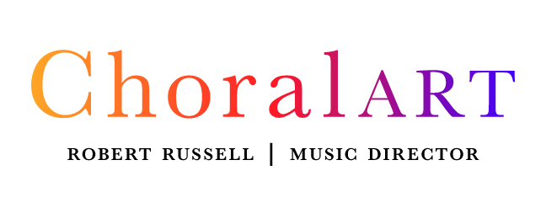
Job Description: Administrative Director, ChoralArt
ChoralArt seeks an Administrative Director to provide administrative leadership for one of the premier choral organizations in Maine. Founded in 1972 by volunteer singers committed to excellence in choral performance, ChoralArt today comprises three auditioned ensembles: an 80-voice symphonic ChoralArt Masterworks, a 40-voice ChoralArt Singers, and a 16-voice ChoralArt Camerata. ChoralArt Masterworks sings annually with the Portland Symphony Orchestra; ChoralArt Singers performs a series of Christmas at the Cathedral concerts to nearly 2000 enthusiastic patrons; and ChoralArt Camerata sings repertoire from Renaissance to modern. Robert Russell has served as Music Director of ChoralArt since 1979.

Position: Part-time, non-exempt, hourly, averaging approximately 25-30 hours/week September–April (peak season), with reduced hours in late spring and summer. Hours may vary depending on seasonal repertoire.
Compensation: Competitive and commensurate with experience and qualifications
Reports to: The Board of Directors and works most closely with the President (chair of the board) and Music Director
Start Date: As soon as possible. Position will remain open until a suitable candidate is found.
Region: Portland
Specific Location: Work is home-based. Ability to travel locally for events and meetings required.

PRIMARY RESPONSIBILITIES:
Operations and Communications
- Responsible and accountable for all non-musical administration of ChoralArt
- Hire, direct and supervise part-time Manager; identify and work with free-lance communications specialists
- Identify opportunities to use volunteers; recruit and manage them as needed, working with President to identify volunteers
- Coordinate across Board committees, volunteers, artists, donors, sponsors, and community partners to support organizational operations and events.
- Develop annual budget in conjunction with Treasurer
- Provide management report at bimonthly Board meetings and coordinate with President, Board, and Executive Committee on activities
- Respond to email and phone inquiries as spokesperson for the organization
- Maintain and update organizational website (WordPress), including event pages, membership updates, and integrated communications content.
Concert Production
- Secure or help arrange concert contracts, performance and rehearsal venues, soloists/instrumentalists, logistics, in coordination with Music Director
- Book venues for all concerts

- Oversee all aspects of concert productions, in conjunction with Music Director, Manager, Logistics Committee
- Oversee production of concert program books

Marketing
- Develop marketing plan for each season's concerts, in conjunction with Marketing Committee
- Execute marketing plan and creation of promotional materials, in conjunction with freelance designer
- Place ads for concerts in print and radio media, send emails to patrons, post on social media, secure media coverage to promote events
- Secure advertisements and sponsorships for the organization

Development
- Design and implement annual fundraising appeal, in conjunction with President and Development Committee
- Research and identify potential grants and sponsorships, in conjunction with Development Committee
- Write and submit grant proposals
- Maintain donor stewardship communications, including acknowledgment systems and segmented outreach lists.

Responsibilities may evolve over time in response to organizational needs, and additional duties may be assigned in support of ChoralArt’s mission.

QUALIFICATIONS AND SKILLS:
- Strong writing, editing and verbal communication skills
- Experience overseeing production of concerts (or equivalent)
- Proficient with Microsoft Word and Excel, helpful to have familiarity with software programs for accounting (Quickbooks), fundraising (Little Green Light) and ticketing (Arts People), and for communications with Constant Contact
- Strong leadership and organizational management skills, working with staff and volunteers
- Experience with social media and traditional marketing outlets
- Experience with grant writing
- Ability to work both independently and as a team member
- A passion for the arts, choral music in particular

For more information, please see www.choralart.org

To Apply: Please send letter of interest and resume to Ann Elderkin, ChoralArt Search Committee Chair, annelderkin@gmail.com

ChoralArt is an equal opportunity employer and will not discriminate on the basis of race, color, creed, religion, national origin, sex, gender identity, sexual orientation, marital status, veteran status, genetic information, ancestry, age, political or union affiliation, pregnancy or related medical conditions, veteran status, or any other status or classification protected by applicable law. Disabilities will be considered only as they may relate to the candidate’s ability to fulfill job requirements.

May 1, 2026

