Museum Director Ad
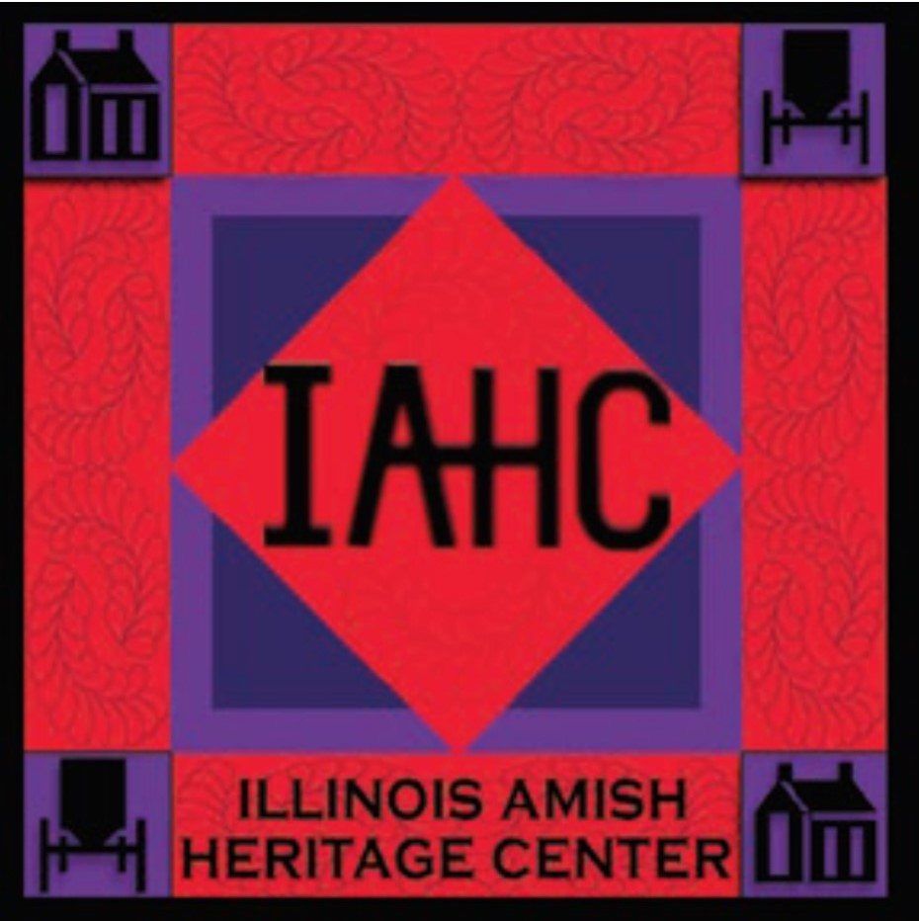
8/21/25

Illinois Amish Heritage Center,
Museum Director

The Illinois Amish Heritage Center (IAHC), located in Arthur, IL (just 30 miles south of Champaign), representing one of the largest Amish settlements in the U.S., seeks its first Museum Director.

Founded in 1997, the IAHC has had several sites. In 2017, it acquired 7.5 acres to develop a Living History Farm & Amish Museum. Since then, two original 1860’s Amish homes have been moved on site and restored along with a workshop, a one-room schoolhouse, and a historic barn. Gardens and a pavilion for school groups have been installed. A signature facility, the Visitor’s Center & Museum (10,000 sq. ft.), is under construction and will open in 2026.

Two annual festivals and monthly educational programs feature Amish life and rural Midwest life in earlier centuries to attract schools, tour groups and visitors from throughout the United States and beyond.

As the first museum director, it is a unique opportunity to develop educational exhibits, establish system and operations, hire staffing, and build educational programs that will shape its future. Responsibilities include strategic planning, financial and operations management, fundraising, and overseeing collection management, exhibitions, educational programs, property, facilities and grounds, volunteers, staff, public relations, communications and marketing and engagement the community and donors. Excellent opportunity for recently retired museum director to apply expertise to shape cultural museum for the future.

Qualifications include minimum of a bachelor’s degree or advanced degree in museum studies, nonprofit management, cultural studies or related field. At least 5-years executive experience in museum management or nonprofit environment or commensurate role with a museum is required. Strong management and leadership skills, knowledge of museum practices, and experience in budgeting, financial management, marketing, fundraising, grant writing and strategic planning are preferred.

Salary range is $60,000-$70,000. Included is a hybrid work schedule, 4-week vacation with reduced hours during winter months and benefit options valued at $7500 for individual to purchase their own or to use for a section 125 cafeteria plan.

To apply send cover letter, resume and references to admin@illinoisamish.org or Illinois Amish Heritage Center, PO Box 284, Arthur, Illinois 61911.

