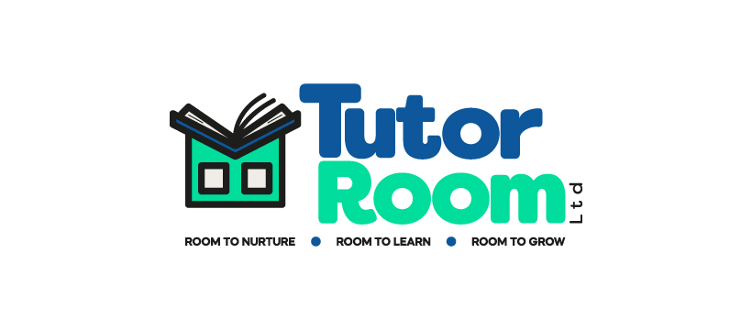
Statement of Purpose
Tutor Room Ltd

At Tutor Room Ltd, we believe every child has the potential to thrive when given the right support, encouragement, and environment. Our mission is to help children regain confidence, catch up on lost learning, and reignite their curiosity through personalised, nurturing, and engaging tuition.
Our community of experienced, fully qualified teachers from Brighton & Hove and across the UK share a passion for making learning inspiring and effective. Having worked in mainstream schools, they know first-hand that one size does not fit all. Tutor Room Ltd tailors every lesson to the unique needs of each child, ensuring they feel safe, happy, and motivated to succeed.

Our Core Values

- Room to Nurture: Every child deserves to feel valued and supported. When children feel safe and cared for, they are empowered to learn and grow.
- Room to Learn: Learning should be fun, dynamic, and tailored to meet each child’s individual needs and goals.
- Room to Grow: With personalised guidance, there are no limits to what a child can achieve as they progress through their education.

Primary Tuition (KS1 and KS2)
For younger learners, we focus on making learning fun and engaging! Our tutors build strong, trusting relationships with children, boosting their self-confidence and accelerating progress. Many of our primary learners go from below-average performance to exceeding expectations within months. We’re proud of our outstanding SATs results, but even more importantly, we love seeing children empowered and excited about learning.

Secondary Tuition (KS3 and KS4)

Our secondary tutors, based across the UK, are experts in their subjects and many have worked as GCSE and A-level examiners. They understand the challenges of exams and the anxiety they can bring, so they focus on creating a calm, supportive environment where learners can thrive.
We offer 1:1, paired, or small group tuition (up to four learners) in a range of subjects, including:
- Mathematics (Foundation and Higher)
- English (Language and Literature)
- Science (Combined and Triple)
- History, Geography, Business Studies, Languages, Music, and more.
Whether building confidence in year 7 or preparing for A-levels, our tutors help learners tackle challenges and achieve their full potential.

Special Educational Needs and Disabilities (SEND)

Every child is unique, and our experienced SEND tutors are skilled at supporting children with a wide range of needs, including:
- Autism Spectrum Disorder (ASD), ADHD, and Dyslexia.
- Anxiety-based school avoidance and attachment difficulties.
- Developmental Language Disorder, Dyspraxia, and more.
We provide a nurturing, understanding environment that helps SEND learners feel valued and capable. Our team works closely with families, often supporting Education, Health, and Care Plans (EHCPs), to ensure each child thrives academically and emotionally.

Home Education

For children unable to attend mainstream schools, whether short or long-term, we offer personalised, supportive tuition. Our experienced tutors understand the unique needs of home-educated learners, helping them succeed academically whilst building their confidence and wellbeing.

At Tutor Room Ltd, we’re more than a tutoring service — we’re partners in your child’s education, committed to unlocking their potential and inspiring a lifelong love of learning. Let’s create room to nurture, room to learn, and room to grow — together.

