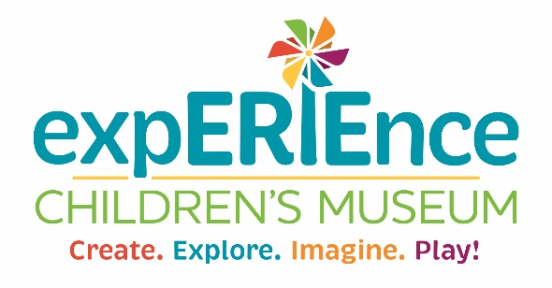
JOB DESCRIPTION
Job Title: Director of Education
Department: Education
Reports to: Assistant Director
Classification: Exempt
Salary Range: $50,000–$52,000 annually
Schedule: Full-time, 40 hours per week
Paid Time Off: 10 days annually
Parking: EM2 designated parking
Retirement Plan: Simple IRA with a 3% employer match, available after 90 days of employment
Health Insurance: Employer covers 60% of premium; employee contributes 40%
Dental and Vision Insurance: 100% employer-paid

Position Overview:
This position leads the vision, development, and delivery of the Museum’s educational programming both on and off-site. Following national and Pennsylvania state standards for early childhood education, the Director of Education ensures that all initiatives support the integration of science, technology, engineering, art, and math while creating meaningful family learning experiences. This role supports school readiness and enrichment for children ages birth to 13 years and is responsible for strengthening and growing the Museum’s educational impact.

Essential Duties and Responsibilities:
- Provides leadership for all educational programming, including review and approval of curriculum presented by the museum
- Supervises Assistant Director of Education and part-time Education Lead, including coaching and professional development
- Conducts regular performance reviews and supports staff development
- Directs the education strategic plan to grow participation, revenue, and program quality
- Develops and manages the annual education budget
- Collaborates with the museum’s leadership team to align educational initiatives with organizational goals
- Oversees the creation and implementation of classes, camps, scout programming and teacher workshops as structured educational offerings.
- Leads the creation and delivery of value-added programming (VAP), offering engaging educational experiences included with museum admission
- Carries out educational components of grant-funded initiatives, including deliverables and reporting
- Designs exhibit-based lessons and presentations for both group tours and general visitors
- Ensures exhibits align with educational standards and support clear learning outcomes
- Supports and enhances field trip and group tour experiences with a strong focus on hospitality and organization
- Expands and manages mobile museum programming to increase community reach
- Builds relationships with schools, preschools, and community partners to increase bookings
- Supports planning and implementation of museum events, including adding educational components
- Assists with general museum operations, including customer service and cross-departmental support
- Implements evaluation tools and outcome assessments to measure program effectiveness

Strong Consideration given to:
- Post-secondary degree in Early Childhood Education or related field
- Working knowledge of Pennsylvania State Standards and early childhood developmental theory
- Minimum of 5 years of experience working with families and young children

Required:
- Ability to pass PA criminal record, child abuse history, and FBI fingerprint clearances
- Strong leadership skills with the ability to guide and support a team
- Excellent verbal, written, and interpersonal communication skills
- Strong organizational skills with the ability to manage multiple priorities
- Ability to build relationships with both internal teams and external partners
- Team-oriented mindset with the ability to balance independent responsibilities
- Flexibility to work weekends as needed

