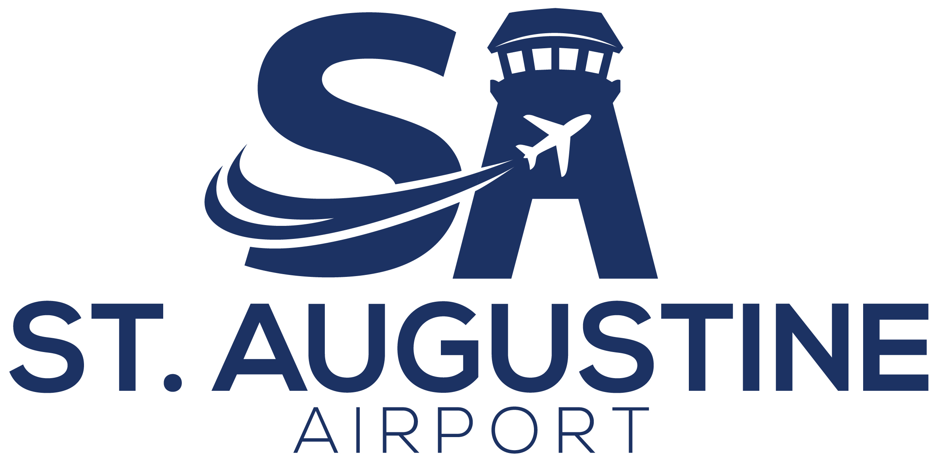
DIRECTOR OF OPERATIONS
St. Johns County Airport Authority
Position Title | Director of Operations
Department | Airport Operations
Reports To | Executive Director
Supervises | Operations and assigned maintenance/facilities personnel
FLSA Status | Exempt
Salary Range | $110,000 - $135,000, commensurate with qualifications and experience

POSITION SUMMARY
The Director of Operations directs the day-to-day operational activities of St. Augustine Airport, ensuring the safe, secure, efficient, and compliant operation of all airside and landside areas, facilities, and infrastructure. The position is responsible for airfield and landside operations, regulatory compliance under 14 CFR Part 139, airport security, environmental and fuel compliance, hangar and property management, emergency management, and the supervision of operations personnel. The Director of Operations serves as a senior operational leader who supports the Executive Director and implements the policies, priorities, and standards established by the Executive Director and the Airport Authority Board.

REPORTING RELATIONSHIP AND SCOPE OF AUTHORITY
The Director of Operations reports directly to the Executive Director and is responsible for executing the Airport's operational, safety, security, and regulatory-compliance functions. In addition to the operational duties described below, the Director of Operations will assist the Executive Director with:
- Strategic planning and the development of Authority goals, policies, and procedures.
- Business and economic development, marketing, and major tenant and community relationships.
- Budget development, capital planning, lease administration, grant programs, and FAA/FDOT grant-assurance compliance.
In these areas, the Director of Operations provides operational leadership, expertise, recommendations, reporting, and presentations in support of the Executive Director and the Board.

ESSENTIAL DUTIES AND RESPONSIBILITIES

Airside and Landside Operations
- Direct daily airside and landside operations to ensure the safe, secure, and efficient movement of aircraft, vehicles, and people.
- Conduct and oversee daily inspections of runways, taxiways, ramps, signage, lighting, pavement, fencing, and landside areas; identify and correct unsafe or non-conforming conditions.
- Issue and manage NOTAMs and coordinate operational matters with the FAA contract control tower.
- Oversee operational safety and coordination during construction projects, special events, and irregular operations.
- Administer ground-transportation, vehicle-access, and airfield-driving programs.
- Coordinate U.S. Customs and Border Protection (CBP) services and facilitate international (User Fee) aircraft operations.

Part 139 Compliance and Airport Certification
- Maintain compliance with 14 CFR Part 139 and the Airport Certification Manual (ACM), and serve as a primary point of contact for FAA Part 139 inspections.
- Ensure timely corrective action on inspection findings and maintain required operational records, logs, and FAA publications.
- Administer the Wildlife Hazard Management Plan and coordinate wildlife mitigation.
- Lead the Airport's Safety Management System (SMS) and operational safety programs.
- Administer the airfield self-inspection program and train operations staff on Part 139 self-inspection requirements.
- Maintain and submit required FAA data and reports, including the Airport Master Record (FAA Form 5010), operations counts, and based-aircraft data.

Fuel, Environmental, and Noise Compliance
- Oversee fuel farm and fueling operations, including fuel storage, quality control, recordkeeping, and fueling safety.
- Manage environmental compliance, including Spill Prevention, Control, and Countermeasure (SPCC) plans, aboveground and underground storage tanks, stormwater, and fuel-contamination issues.
- Administer the noise abatement program, monitor aircraft noise, and respond to and track noise complaints.
- Lead sustainability and energy-management initiatives.

Airport Security
- Oversee airport security, including access control, gates, perimeter fencing, vehicle access, and CCTV systems.
- Administer the airport credentialing and badging program and authorize access to restricted and operational areas.
- Manage security investigations and implement corrective measures for security incidents and violations.
- Coordinate with local law enforcement and applicable federal and state agencies on security matters.

Maintenance, Facilities, and Capital Projects
- Oversee maintenance of the airfield, facilities, grounds, utilities, signage, and lighting — including the pavement management program (PCI) — to ensure reliability and regulatory compliance.
- Coordinate preventive maintenance through the work-order/CMMS system, and monitor contractor and vendor performance.
- Supervise and manage the delivery of capital and construction projects — including coordination of consultants and contractors, construction administration, and scheduling — and manage the operational impact of construction (phasing, airfield safety, and continuity of operations).
- Manage the airport vehicle and equipment fleet and maintain an inventory of tools, equipment, supplies, and materials.
- Oversee custodial and janitorial services and the upkeep of public-facing facilities.

Emergency Management
- Maintain, communicate, and regularly exercise the Airport Emergency Plan (AEP); conduct drills and training to ensure readiness; and coordinate activation of the Emergency Operations Center (EOC).
- Serve in a lead operational role before, during, and after emergencies, incidents, and operational disruptions.
- Coordinate with ARFF, law enforcement, and local, state, and federal response agencies.

Budget and Revenue Support
- Assist the Executive Director in developing and administering the operations budget.
- Monitor operational expenditures; forecast funding needs for staffing, equipment, materials, and supplies; and investigate and report on variances.
- Administer airport rates, fees, and charges and aeronautical revenue (including fuel flowage, tie-down, and hangar fees), and recommend adjustments to the Executive Director.
- Identify opportunities for revenue enhancement and cost optimization.
- Support procurement, bid and RFP preparation, and contract administration for operational services.

Board Reporting and Presentations
- Prepare and deliver operational reports, data, and presentations to the Board of Directors at the direction of the Executive Director.
- Provide recommendations on operational, safety, security, and compliance matters within the position's area of responsibility.

Events, Communications, and Social Media
- Plan, coordinate, and oversee airport events and airshows, including logistics, safety, vendor coordination, and operational impact.
- Hold overall responsibility for the Airport's social media presence, including content development, posting, and engagement across platforms.
- Monitor and respond to inquiries and feedback received through social media, coordinating with the Executive Director on sensitive or strategic messaging.

Stakeholder Engagement
- Build and maintain effective working relationships with tenants, business partners, regulatory agencies, and community stakeholders.
- Conduct tenant and stakeholder surveys to assess satisfaction and identify areas for improvement.
- Assist in representing the Airport at industry conferences, meetings, and public forums to promote the Airport's interests and initiatives.

Tenant, Property, and Hangar Management
- Serve as the operational liaison to airport tenants, fixed-base operators (FBOs), the contract tower, and airport users.
- Oversee FBOs and enforce compliance with leases, airport rules and regulations, and minimum standards, and resolve operational issues.
- Conduct hangar inspections and enforce hangar use, compliance, and lease requirements.
- Manage hangar leasing, waitlists, and hangar development.
- Manage airport land and property, including use agreements and the development of airport property.
- Review tenant improvement and construction plans and oversee related permitting and compliance.
- Coordinate operational needs with major tenants and partners, including Northrop Grumman.
- Maintain and recommend updates to the Airport Rules and Regulations and Minimum Standards.

Administration, Compliance, and Technology
- Manage department records, records-retention, and public records (Sunshine) responses within the department's area of responsibility.
- Administer the Disadvantaged Business Enterprise (DBE) program.
- Administer risk management, insurance, and workers' compensation programs, and track tenant and vendor certificates of insurance (COI).
- Oversee the Airport's information technology systems, infrastructure, and cybersecurity.

Personnel and Supervision
- Recruit, train, schedule, supervise, and evaluate operations and assigned maintenance personnel, and lead talent acquisition, development, and retention to build a high-performing workforce.
- Develop staff training and certification programs, including AAAE Airport Certified Employee (ACE) credentials.
- Develop, implement, and maintain standard operating procedures (SOPs) and operational policies.
- Establish operational goals and performance metrics.
- Foster a culture of safety, accountability, and continuous improvement.

MINIMUM QUALIFICATIONS
- Bachelor's degree in Aviation Management, Aeronautical Science, Business Administration, Public Administration, or a related field.
- Minimum of five years of progressively responsible airport operations experience, including at least three years in a supervisory capacity.
- Experience at a Part 139 airport.
- Working knowledge of 14 CFR Parts 77 and 139 and applicable airport safety and security regulations.
- Valid Florida Driver's License, or ability to obtain one within thirty (30) days of hire.
- FEMA ICS courses (ICS 100, 200, 700, and 800), or ability to obtain within ninety (90) days of hire.

PREFERRED QUALIFICATIONS
- AAAE Certified Member (CM) and/or Accredited Airport Executive (AAE) designation.
- AAAE Airport Certified Employee (ACE) credential in Operations, Security, or Airfield Lighting.
- Private Pilot License (current or expired).
- Experience presenting to governing boards or executive leadership.

KNOWLEDGE, SKILLS, AND ABILITIES
- Knowledge of airport operations, maintenance, safety, security, and emergency management principles and practices.
- Knowledge of FAA and applicable federal, state, and local regulations.
- Knowledge of fuel-storage, environmental (SPCC/stormwater), FAA grant-assurance, and Florida public-records (Sunshine) requirements.
- Knowledge of navigational aids (NAVAIDs), airfield lighting systems, and aviation data software.
- Ability to react quickly, appropriately, and calmly in emergency and irregular situations.
- Strong supervisory, organizational, communication, and report-writing skills.
- Ability to build effective working relationships with staff, tenants, agencies, and the public.

PHYSICAL AND WORKING CONDITIONS
- Field-based role requiring frequent walking and driving across airfield, construction sites, and facilities, indoors and outdoors in varying weather.
- Ability to lift and carry up to 25 pounds occasionally.
- Varied schedule that may include days, evenings, nights, weekends, and holidays.
- Subject to emergency call-in; must be available to respond before, during, or after emergencies as assigned.
This job description is intended to describe the general nature and level of work performed. It is not an exhaustive list of all duties, responsibilities, or qualifications, and may be amended at the discretion of the St. Johns County Airport Authority. Furthermore, they do not establish a contract for employment and are subject to change at the discretion of the employer.

