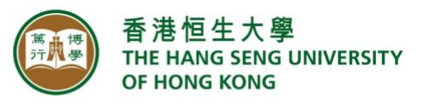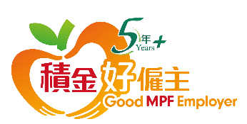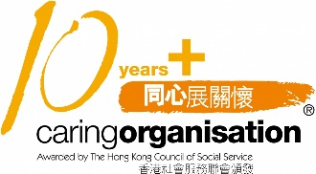

The Hang Seng University of Hong Kong (HSUHK) is a non-profit private liberal-arts-oriented university with six Schools (Business, Communication, Decision Sciences, Humanities and Social Science, Translation and Foreign Languages, and Transdisciplinary Studies), and over 7,000 full-time undergraduate and postgraduate students. With its unique “Liberal + Professional” education model, HSUHK nurtures young talent with critical thinking, innovative minds, caring attitudes, moral values and social responsibility.

Aspiring to be a leading private university in the region, HSUHK prioritises stellar undergraduate education, top-quality faculty members, award-winning green campus facilities, innovative degree programmes, a unique residential college system that combines living and learning, interactive small-class teaching, close student-teacher relationships, impactful research, and excellent student development and support services.

HSUHK has earned various international recognitions. In the AppliedHE’s ALL ASIA Private University Ranking 2026, it secured 7th place in the Greater China region. HSUHK ranked 22nd in Social Sciences and Humanities and 33rd in Economics and Finance among China’s top universities in the Research.com Top Universities and Top Scientists Rankings 2025. The MSc in Global Supply Chain Management programme achieved 84th place globally in the QS International Trade Rankings 2025. Additionally, HSUHK’s School of Business obtained AACSB International accreditation in 2023, a mark of excellence held by only 6% of the world’s leading business schools. HSUHK was also ranked among the top 200 worldwide on “Quality Education” and “Decent Work and Economic Growth” in the Times Higher Education University Impact Rankings 2021.

The School of Business was accredited by the Association to Advance Collegiate Schools of Business (AACSB) in 2023, placing it among less than 6% of business schools globally. The School is currently pursuing the EQUIS accreditation, underscoring its commitment to continuous improvement and international benchmarking. Aspiring to be a leading international business school in Asia, the School is ranked 7th in Business, Management & Accounting and recognised as the first private university in this category in Hong Kong by the SCImago Institutions Rankings (2025). The School has also been awarded 3 Palmes of Excellence by Eduniversal Ranking (2025), being the first private university in Hong Kong to receive this prestigious accolade. Further, the School has been recognised in the subject area of Business Administration alongside Hong Kong’s leading public universities in the 2025 Shanghai Ranking’s Global Ranking of Academic Subjects (GRAS).

The University now invites applications for the following position:

Department of Marketing - Assistant Professor (Full-time)
(Ref: AsstP (MKT) 2026-03-27)

The Department seeks outstanding candidates who demonstrate the ability to publish in top academic journals and can teach a diverse range of marketing modules. All candidates are expected to engage in service activities and provide added value to our student and stakeholder community.

Applicants should

- possess a PhD degree in a related discipline;
- demonstrate an excellent track record of publications in top-tier journals;
- have teaching experience at tertiary level; and
- show a strong commitment to student engagement and scholarly activities.

The appointee is expected to assume duties in August 2026. Salary will be commensurate with qualifications and experience. Interested applicants should visit https://recruit.hsu.edu.hk/ and submit an application letter and an up-to-date CV to apply for the position. Review of applications will begin soon and continue until the position is filled. Shortlisted candidates will be invited for a campus visit and asked to provide a job talk paper and three recommendation letters. The University reserves the right not to fill the position in this exercise.

Applicants who are not invited to an interview within three months may consider their applications unsuccessful. All information received will be treated in strict confidence, and the data collected will be used for recruitment purposes only. The Personal Information Collection Statement will be provided upon request.

The Hang Seng University of Hong Kong, incorporated in Hong Kong with limited liability by guarantee, is an equal opportunity employer.

